**Practical No.5**

**Perform the following:  
5.1 Simple Queries**

* + 1. **Query Processing on the StudentMarks table:**

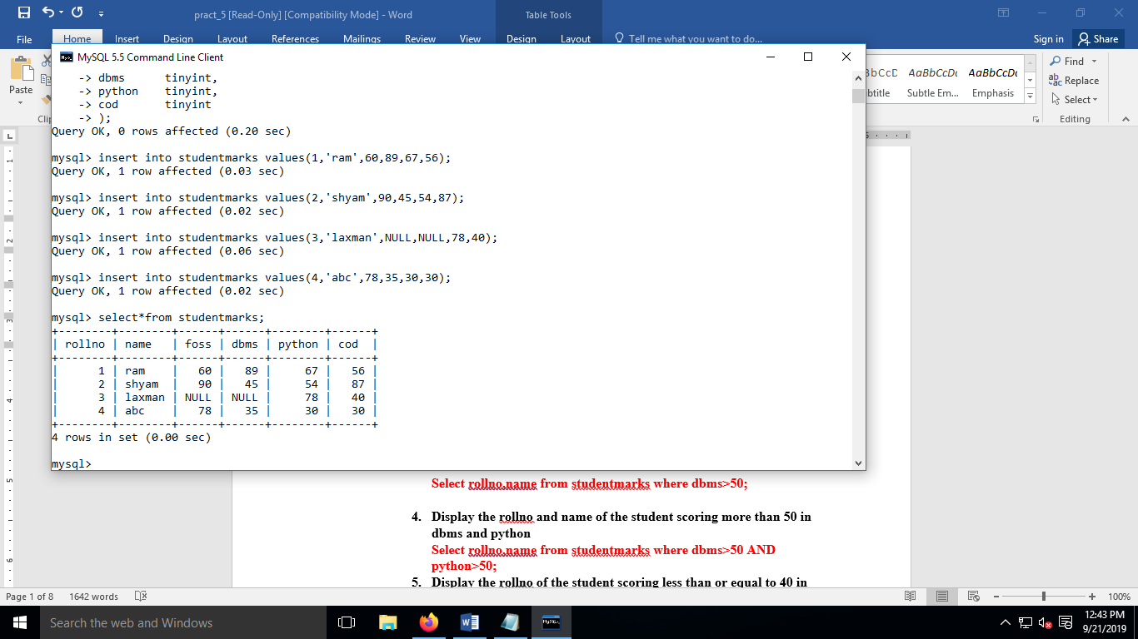

1. **Display the name of the student who’s rollno is 2.**

**Select name from studentmarks where rollno=2;**

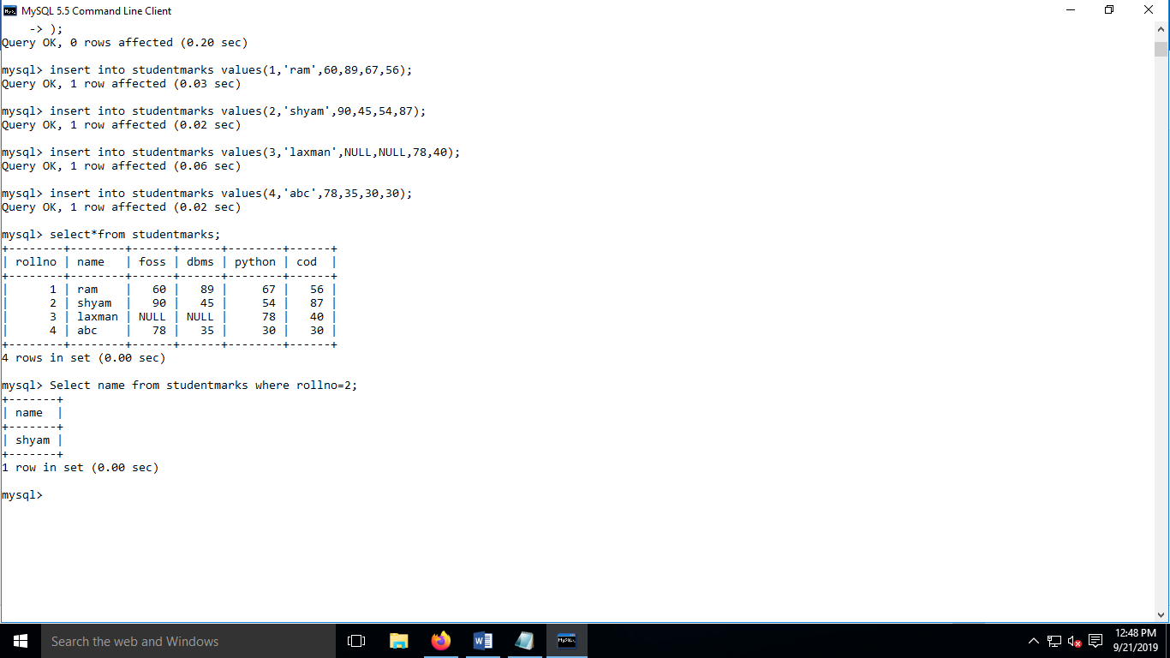

1. **Display the details of the student who’s name is ram.**

**Select * from studentmarks where name=’ram’;**

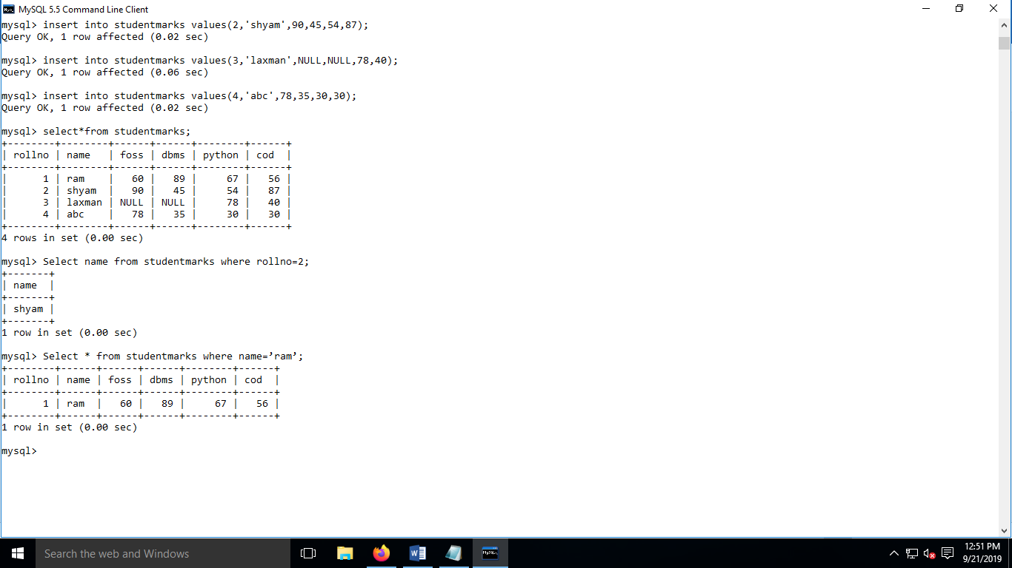

1. **Display the rollno and name of the student scoring more than 50 in dbms.**

**Select rollno,name from studentmarks where dbms>50;**

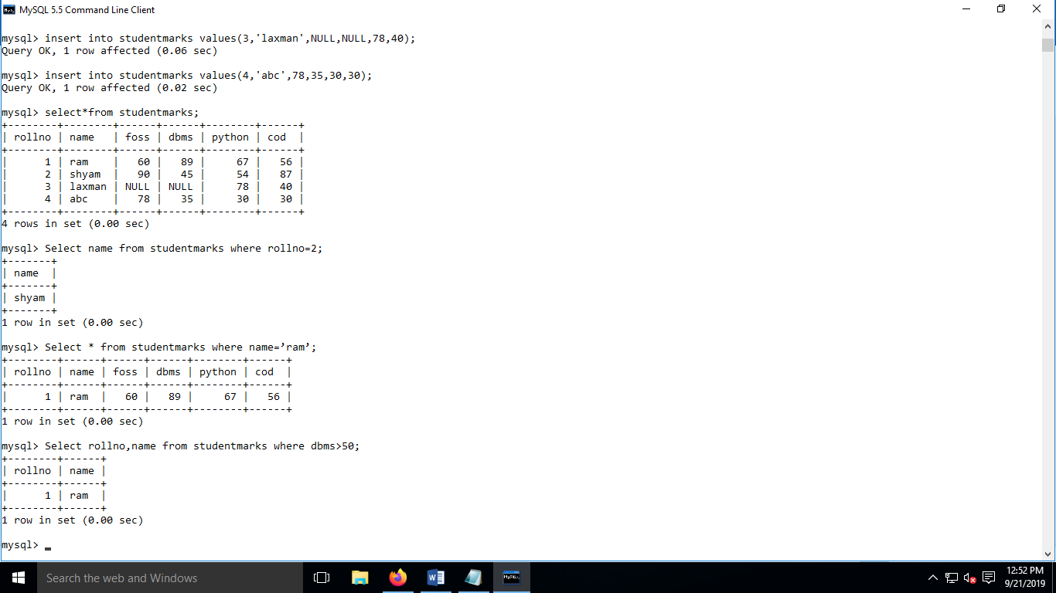

1. **Display the rollno and name of the student scoring more than 50 in dbms and python**

**Select rollno,name from studentmarks where dbms>50 AND python>50;**

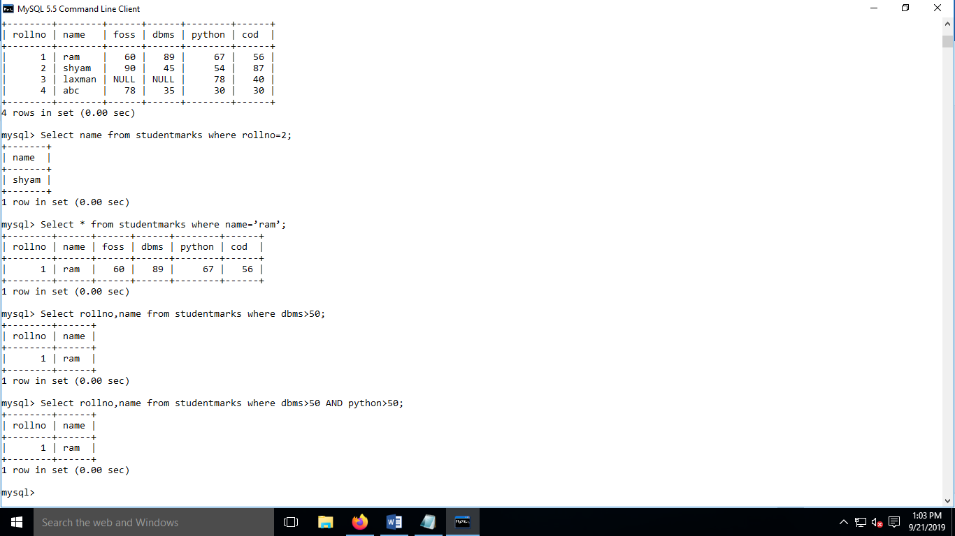

1. **Display the rollno of the student scoring less than or equal to 40 in foss**

**Select rollno from studentmarks where foss<=40;**

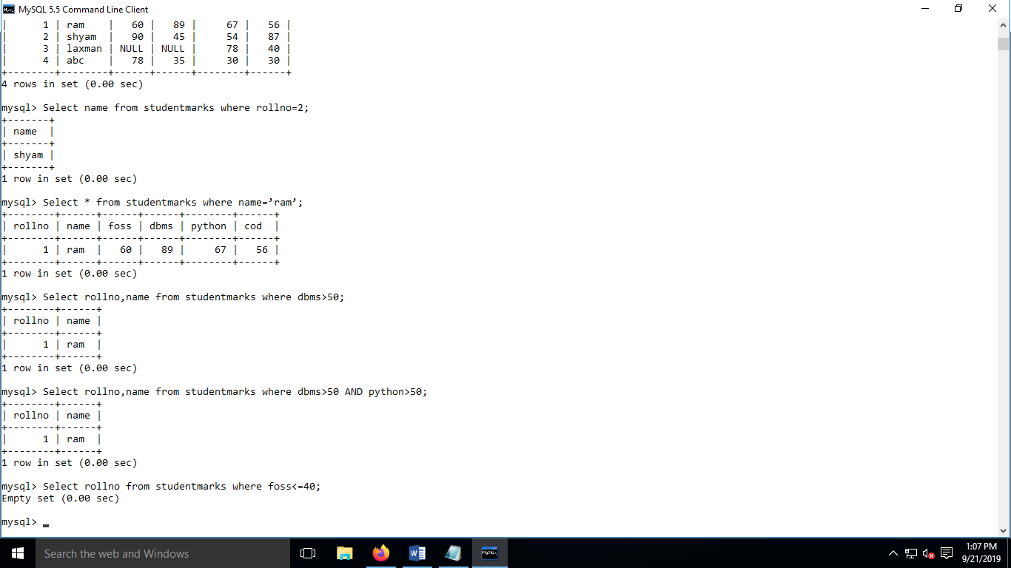

1. **Display the rollno,name and total marks(calculated column) scored by the students**

**Select rollno as ROLL_NO,name as NM,(foss+dbms+python+co) as Total from studentmarks;**

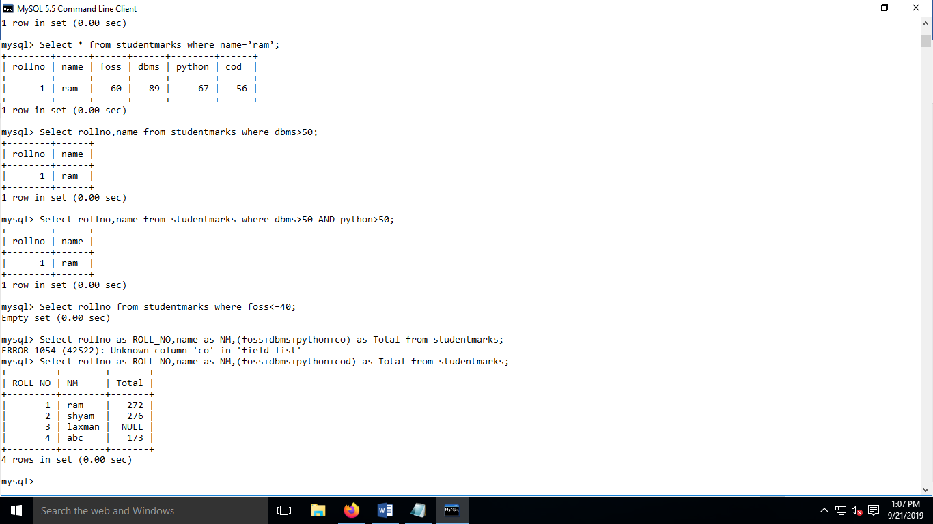

1. **Display the details of the student who’s name is not ram.**

**Select * from studentmarks where name != ’ram’;**

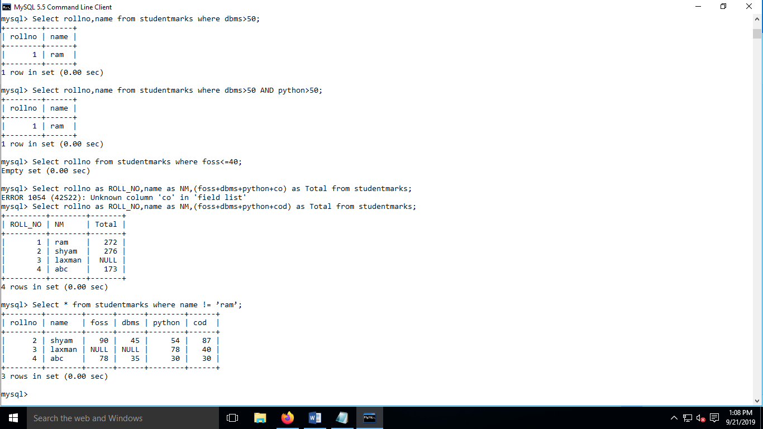

**Select * from studentmarks where name <> ’ram’;**



**Select * from studentmarks where NOT name=’ram’;**



1. **Display the rollno of the student who’s rollno is not 1**

**Select rollno from studentmarks where rollno!=1;**

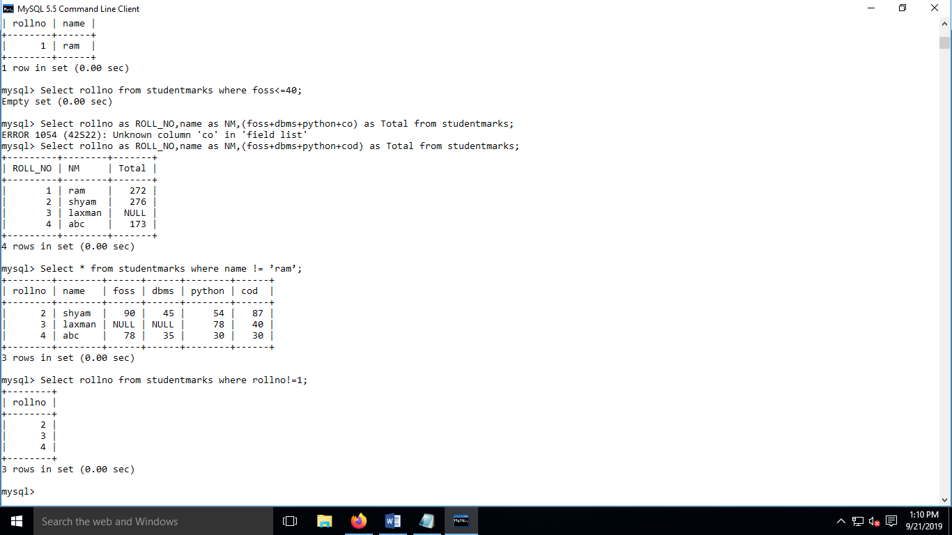

**Select rollno from studentmarks where rollno <> 1;**



**Select rollno from studentmarks where NOT rollno=1;**



1. **Display the details of the student who’s marks in foss is greater than 50 and less than 90**

**Select * from studentmarks where foss>50 and foss<90;**

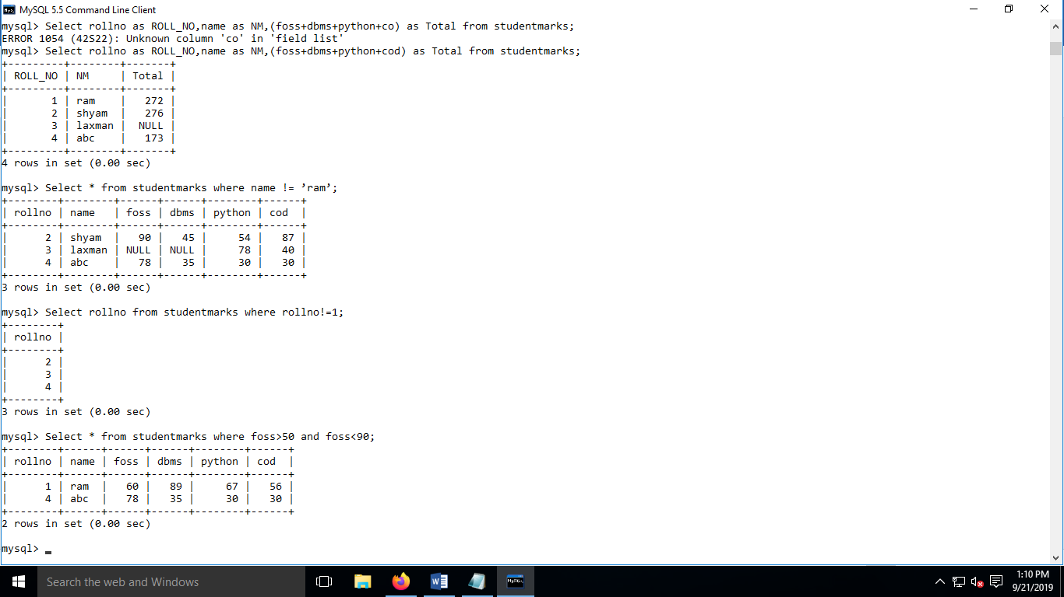

1. **Display the details of the student who’s marks in foss is greater than 40 and marks in dbms is less than 90**

**Select * from studentmarks where foss>40 and dbms<90;**

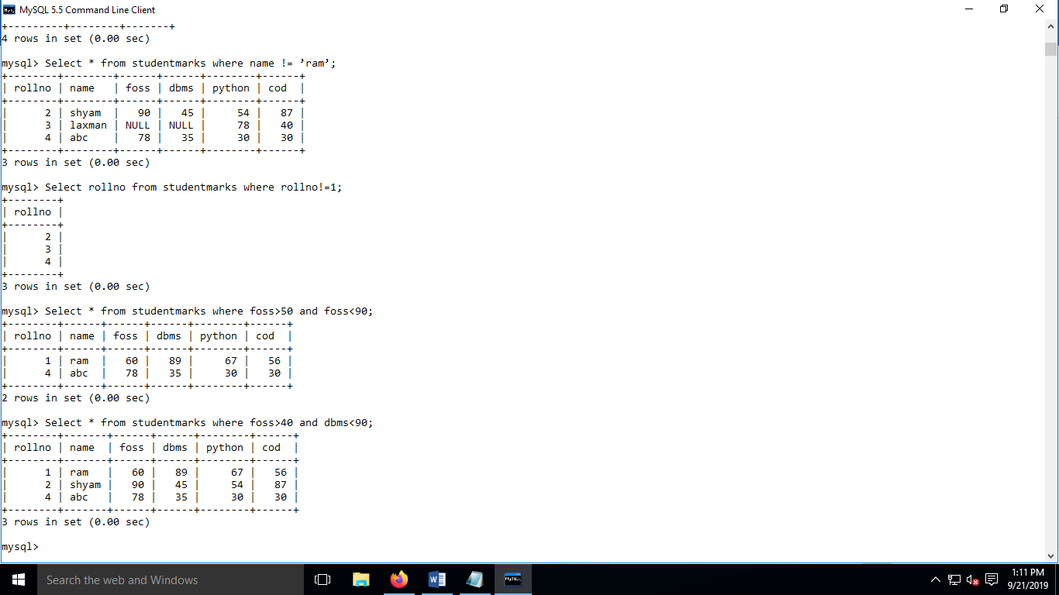

1. **Display the name of the student passing in atleast 1 subject**

**Select * from studentmarks where foss>=40 or dbms>=40 or python>=40 or co>=40;**

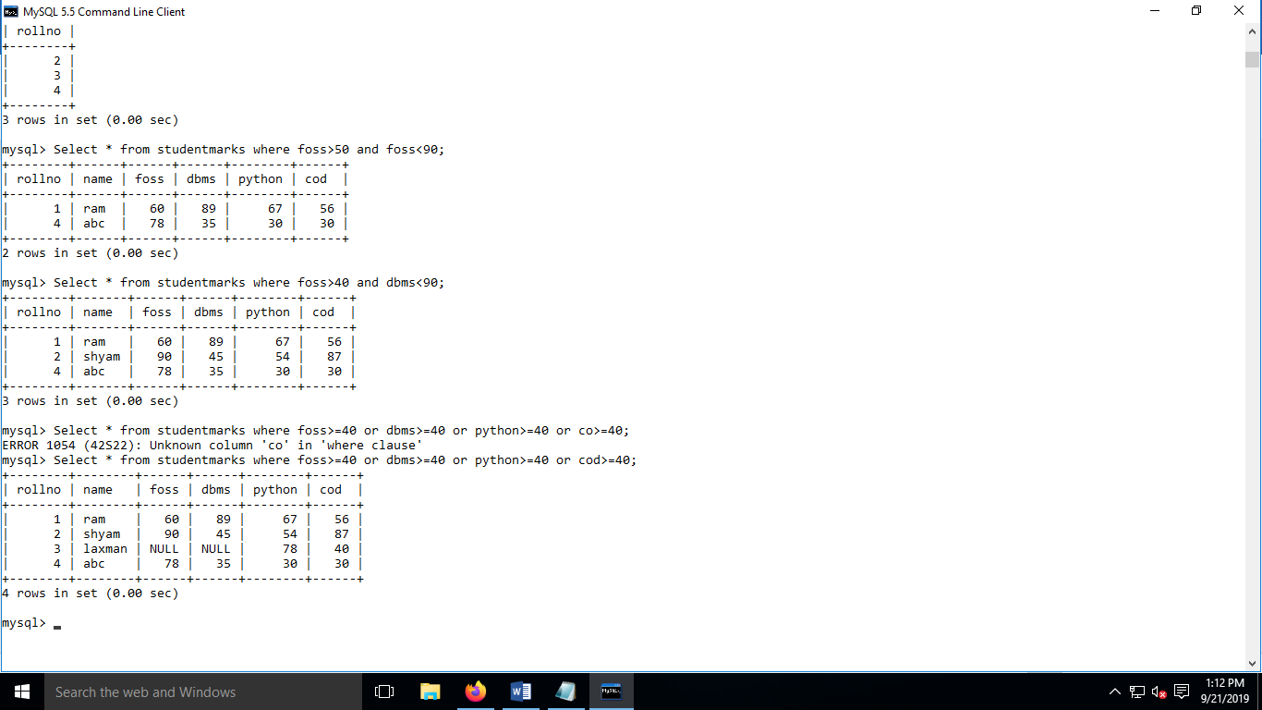

**12.Display the rollno and name of the student passing in atleast 2 subject**

**Select rollno,name from studentmarks where foss>=40 and dbms>=40 or foss>=40 and python>=40 or foss>=40 and co>=40 or dbms>=40 and python>=40 or dbms>=40 and co>=40;**

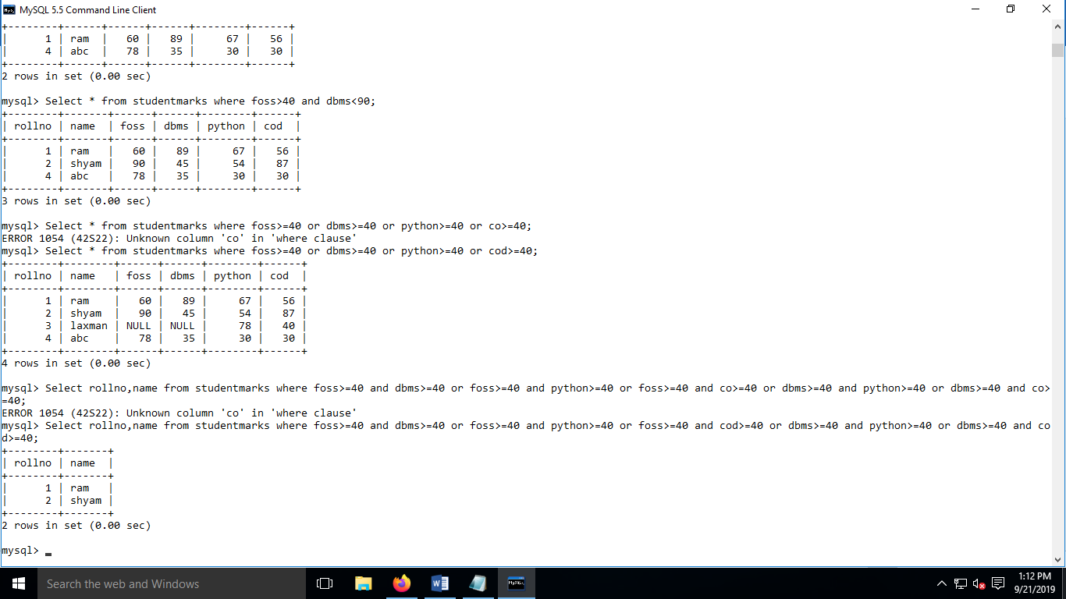

1. **Display the name of the student who’s rollno is 1,2,3(use IN operator)**

**Select name from studentmarks where rollno IN (1,2,3);**

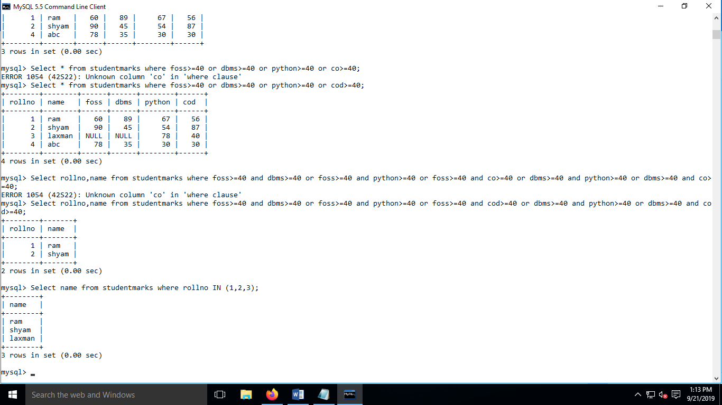

1. **Display the name of the student who’s marks in FOSS subject is from the following list: 10,20,30,40,50,60,70,80,90,100(use IN operator)**

**Select name from studentmarks where foss IN (10,20,30,40,50,60, 70,80,90,100);**

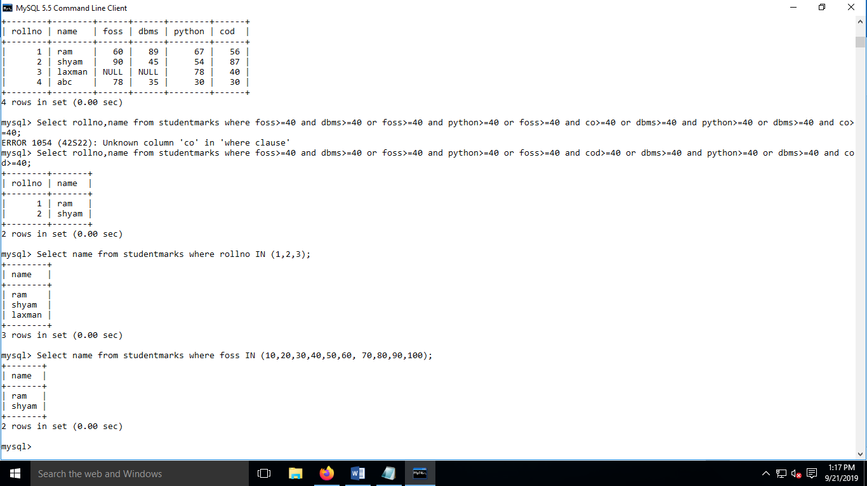

1. **Display the name of the student scoring marks between 40 to 100 in foss.(use BETWEEN operator)**

**Select name from studentmarks where foss between 40 and 100;**

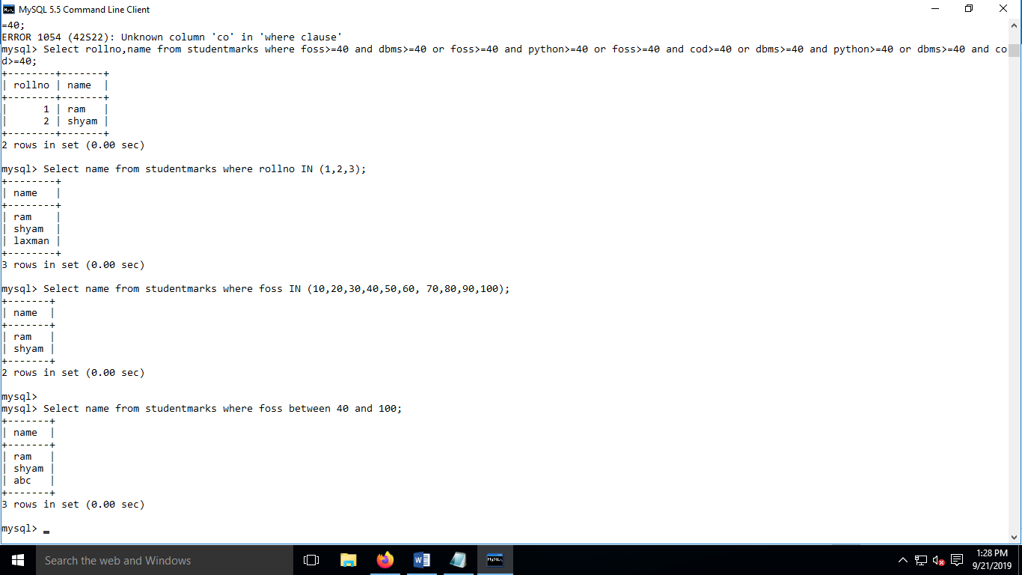

1. **Display the rollno,name and percentage(calculated column)for all students.**

**Select rollno,name,(foss+dbms+python+co)/4 as PERCENTAGE FROM STUDENTMARKS**

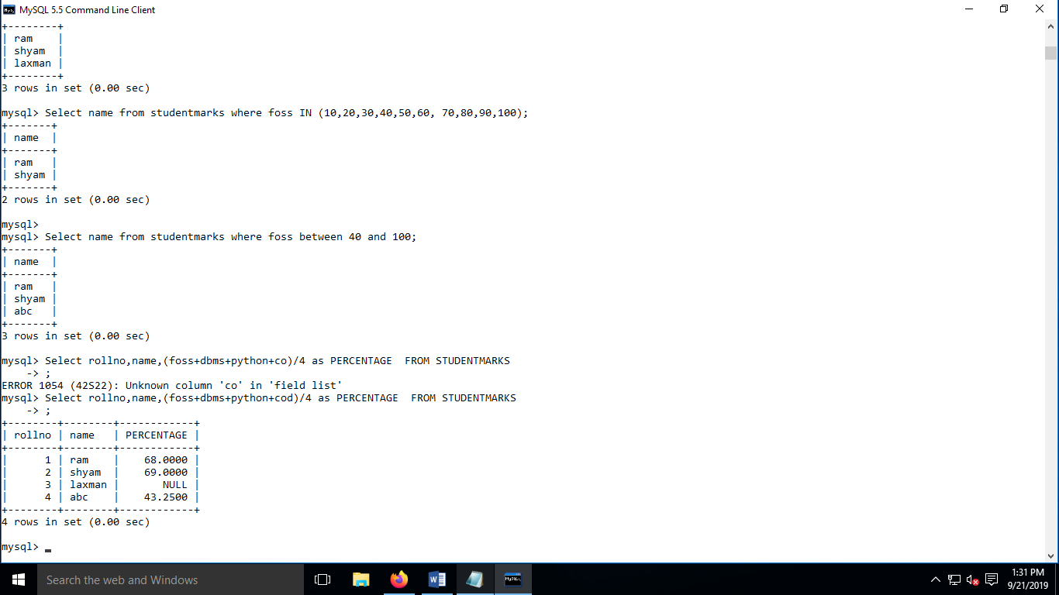

1. **Display the rollno,name of student scoring more than 60%**

**Select rollno,name,(foss+dbms+python+co)/4 as PERCENTAGE FROM STUDENTMARKS**

**Where ((foss+dbms+python+co)/4 )>60;**

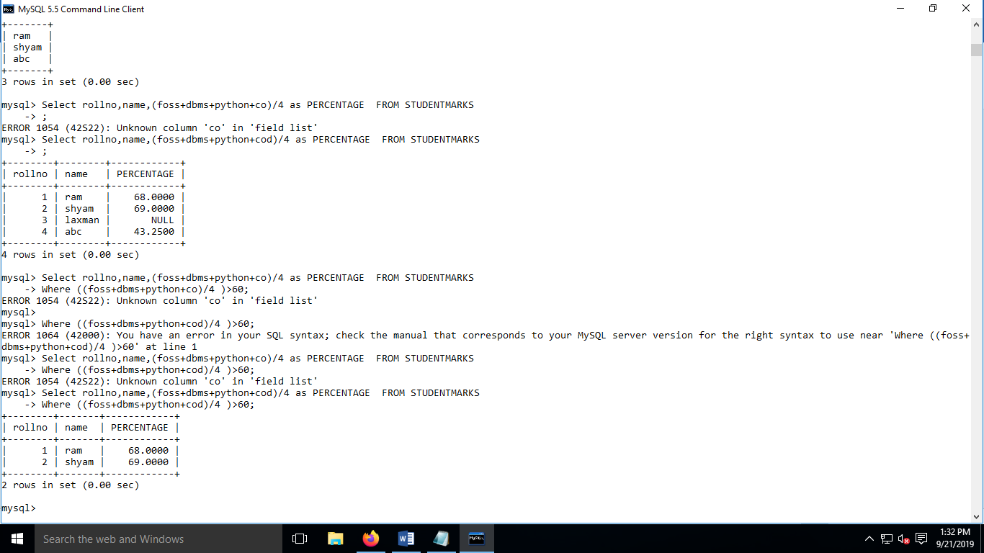

**5.1.2 Consider the following given table**

**StudentGrade**

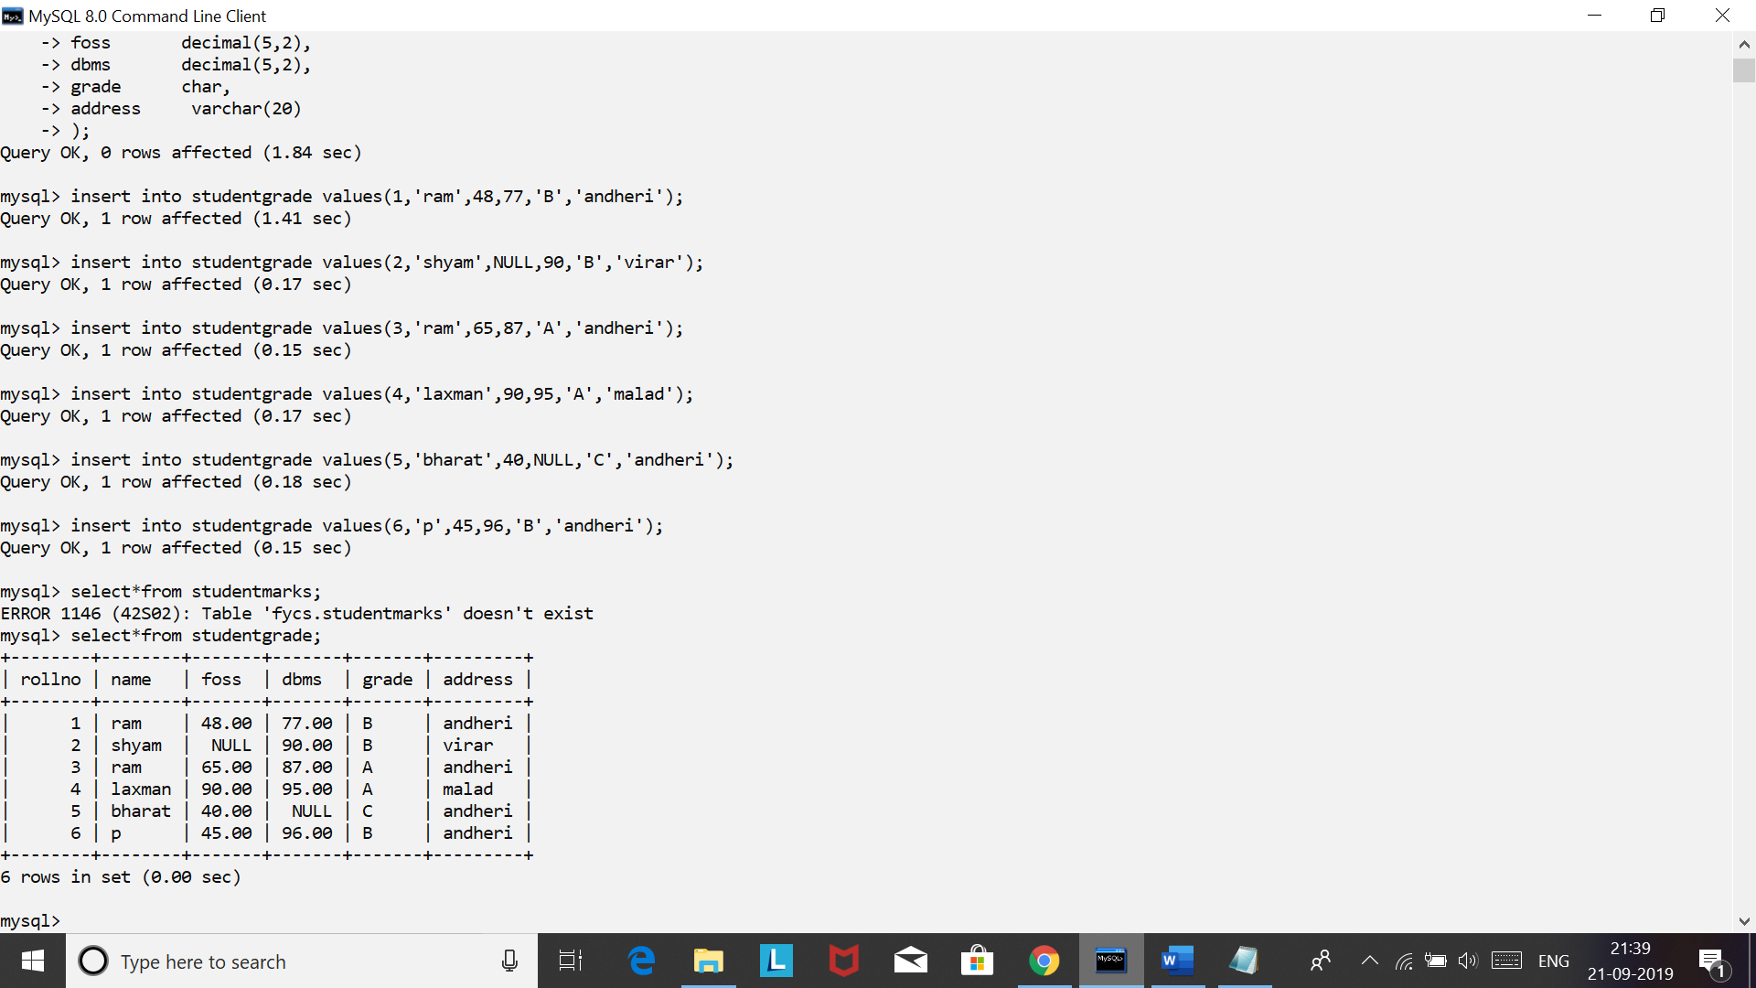

**Q1. Solve the following queries using LIKE operator on StudentGrade table:**

1. **Display the rollno of the student who’s name starts with ‘s’**

**Select rollno from studentgrade where name LIKE ‘s%’;**

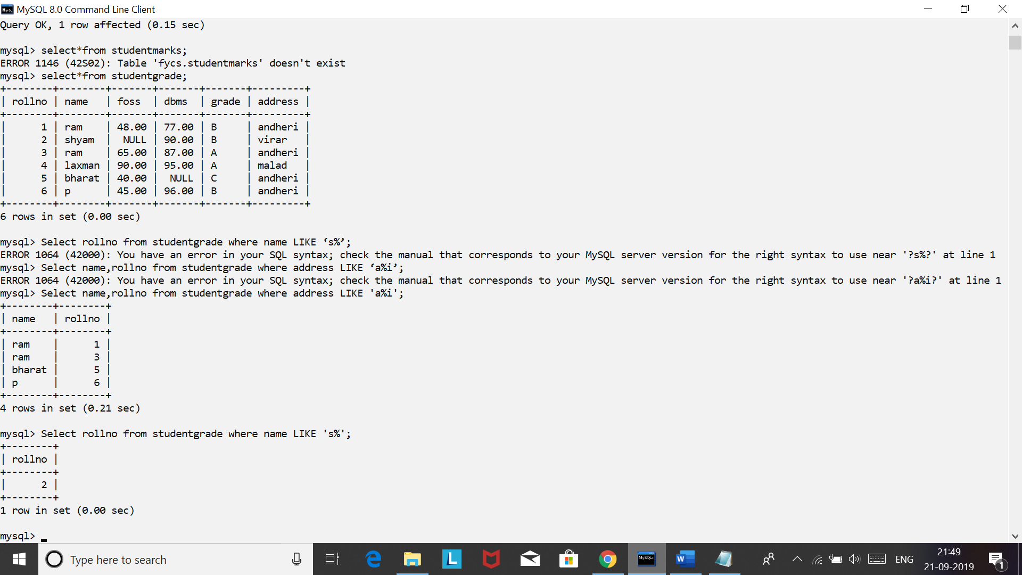

1. **Display the name,rollno of the student who’s address starts with ‘a’ and ends with ‘i’**

**Select name,rollno from studentgrade where address LIKE ‘a%i’;**

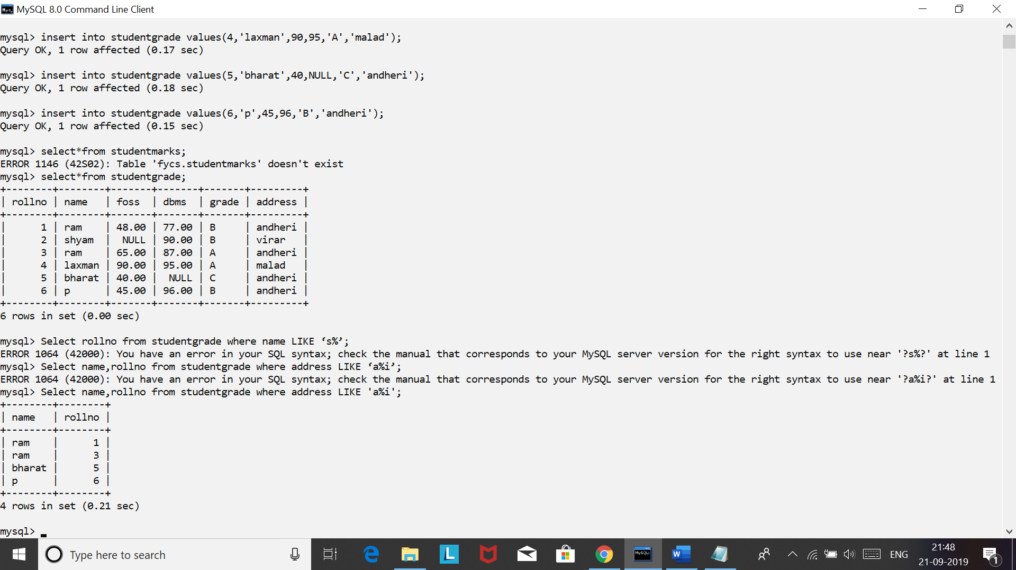

1. **Find the grade of the student who’s name ends with ‘m’**

**Select grade from studentgrade where name like ‘%m’;**

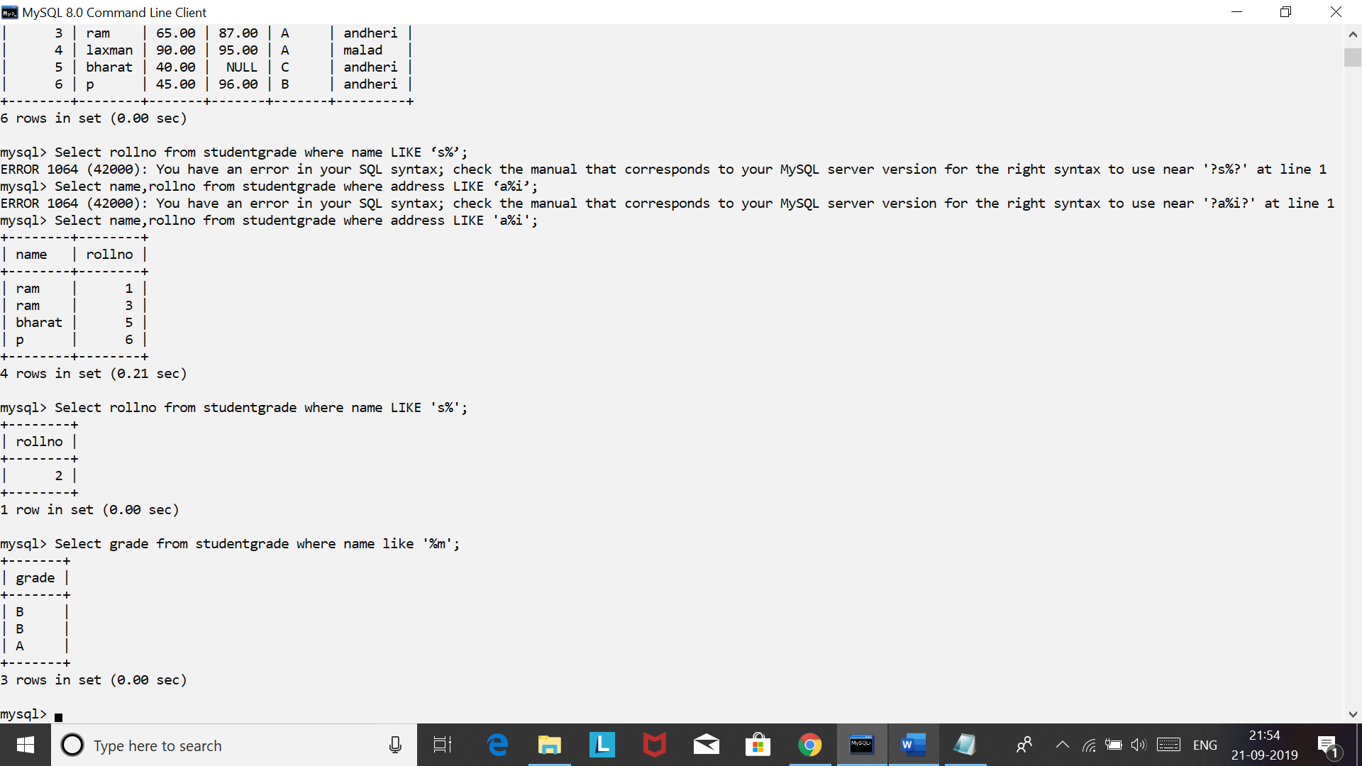

1. **Display the rollno, grade of the student who’s name comprises of 3 alphabet’s only.**

**Select rollno,grade from studentgrade where name like ‘___’;**

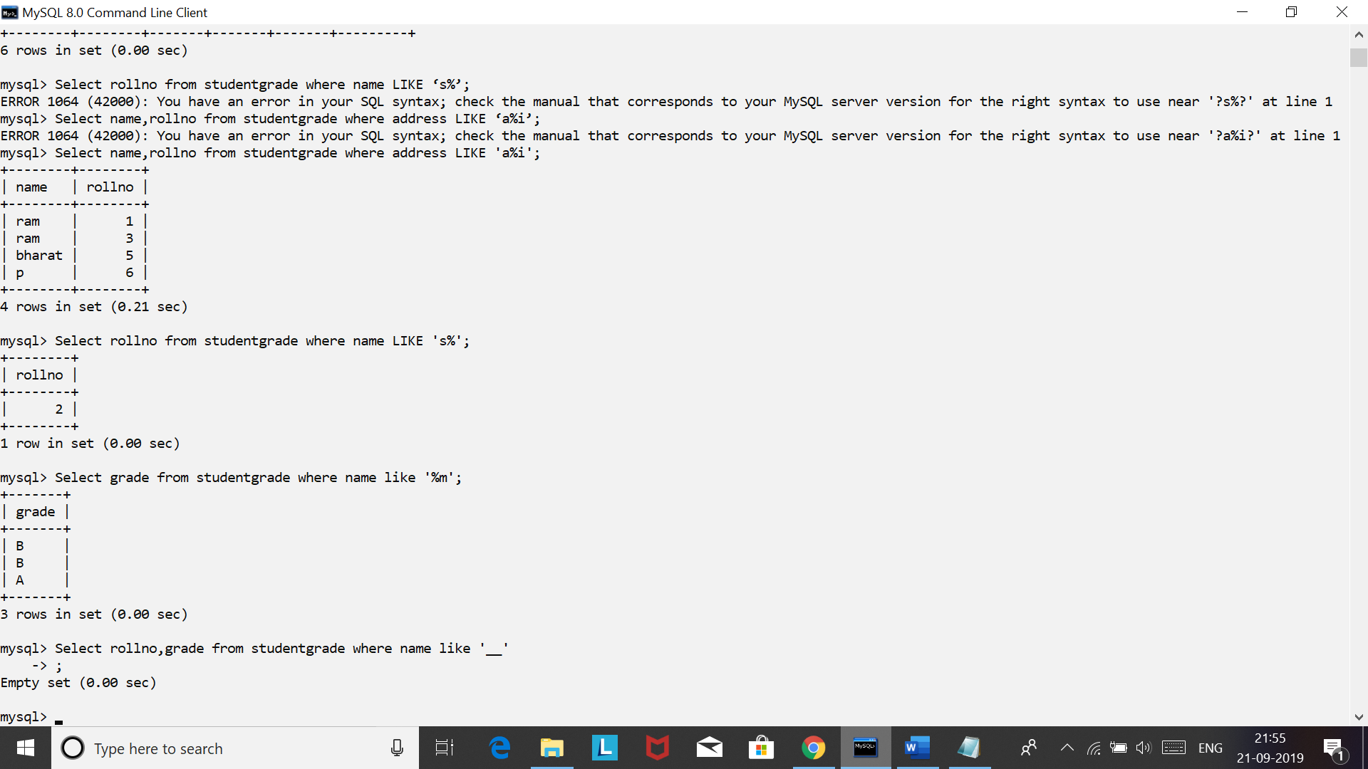

1. **Display the rollno,name of the student who’s address comprises of alphabet ‘ L‘ in it.**

**Select name,rollno from studentgrade where address LIKE ‘%L%’;**

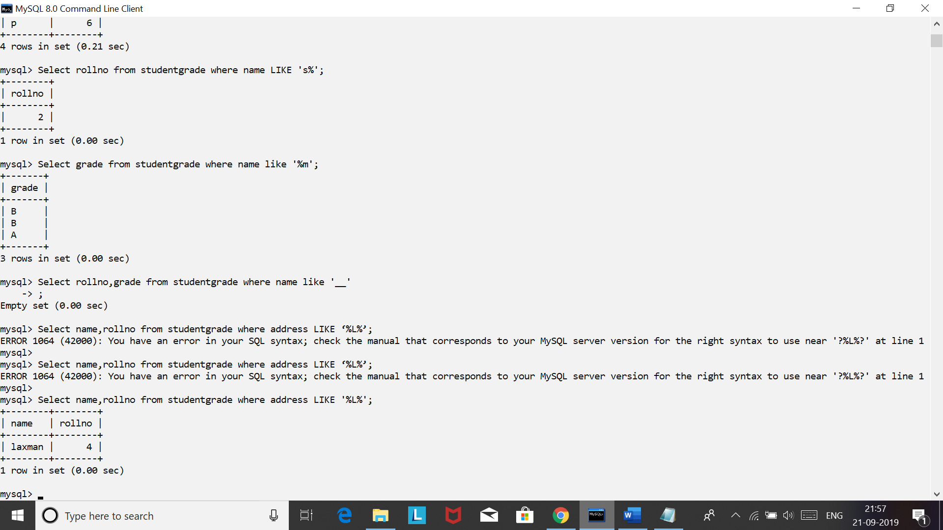

**Q2. Solve the following queries using REGEXP operator on StudentGrade table:**

1. **Display the rollno,name of the student who’s address comprises of pattern ‘an’ in the beginning**

**Select rollno,name from studentgrade**

**Where address REGEXP ‘^an’**

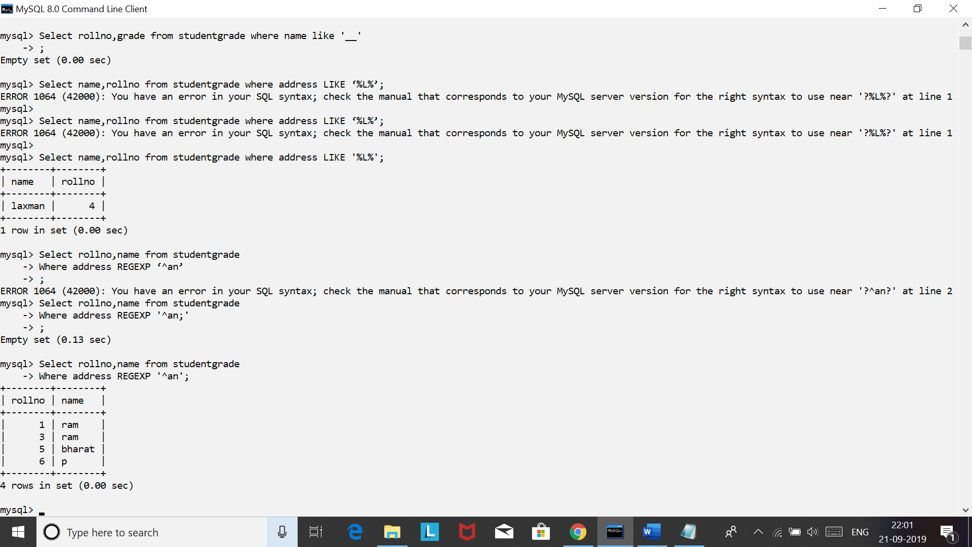

1. **Display the rollno,grade,foss,dbms of the student who’s address comprises of pattern ‘rar’ at the end**

**Select rollno,grade,foss,dbms from studentgrade**

**Where address REGEXP ‘rar$’;**

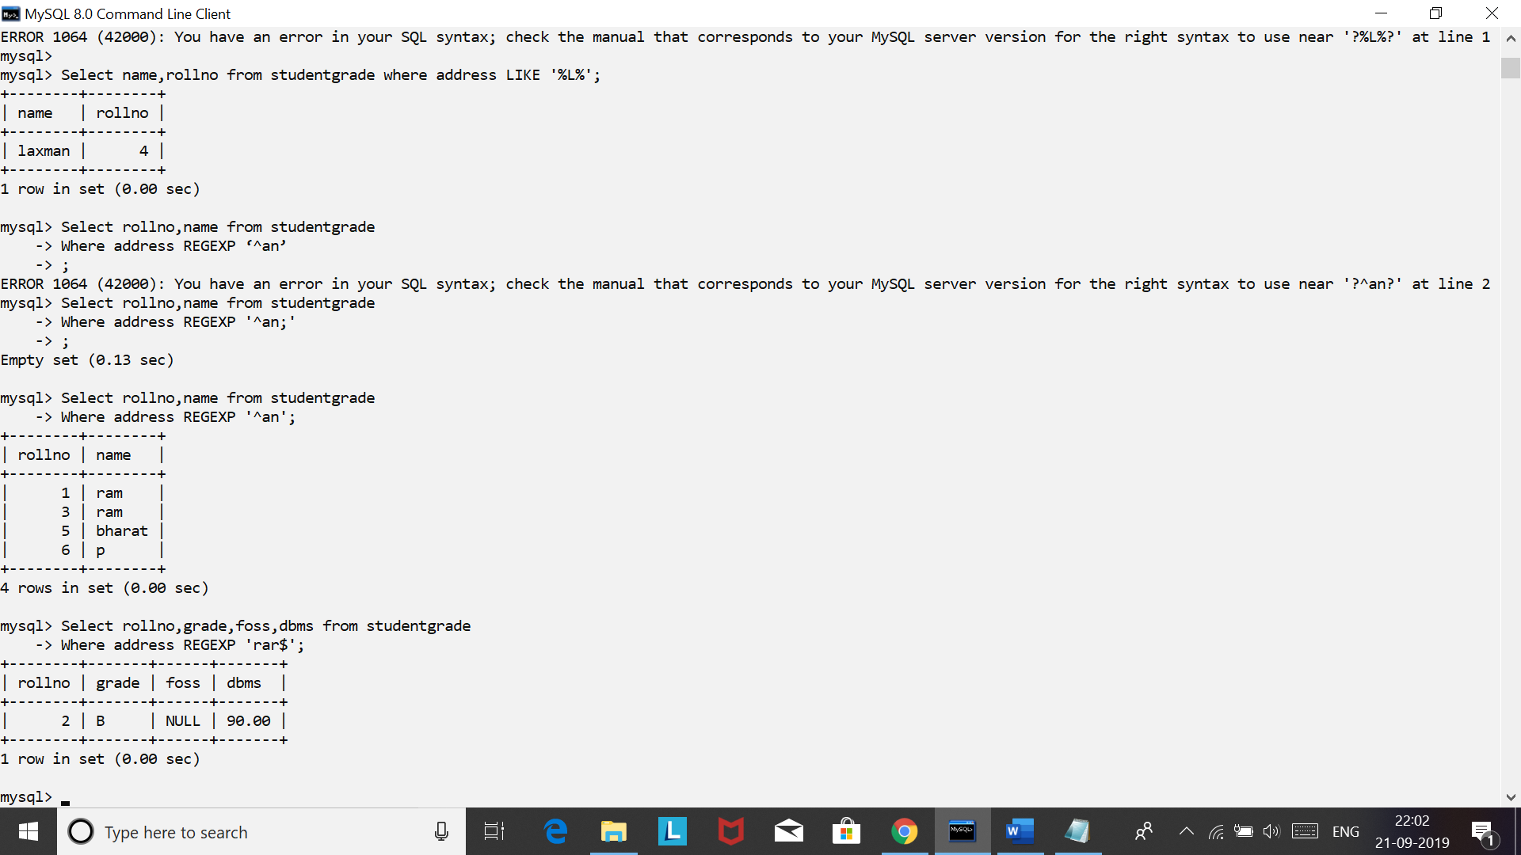

1. **Find the rollno of the student who’s name comprises of single character**

**Select rollno from studentgrade**

**Where name REGEXP ‘^.’**

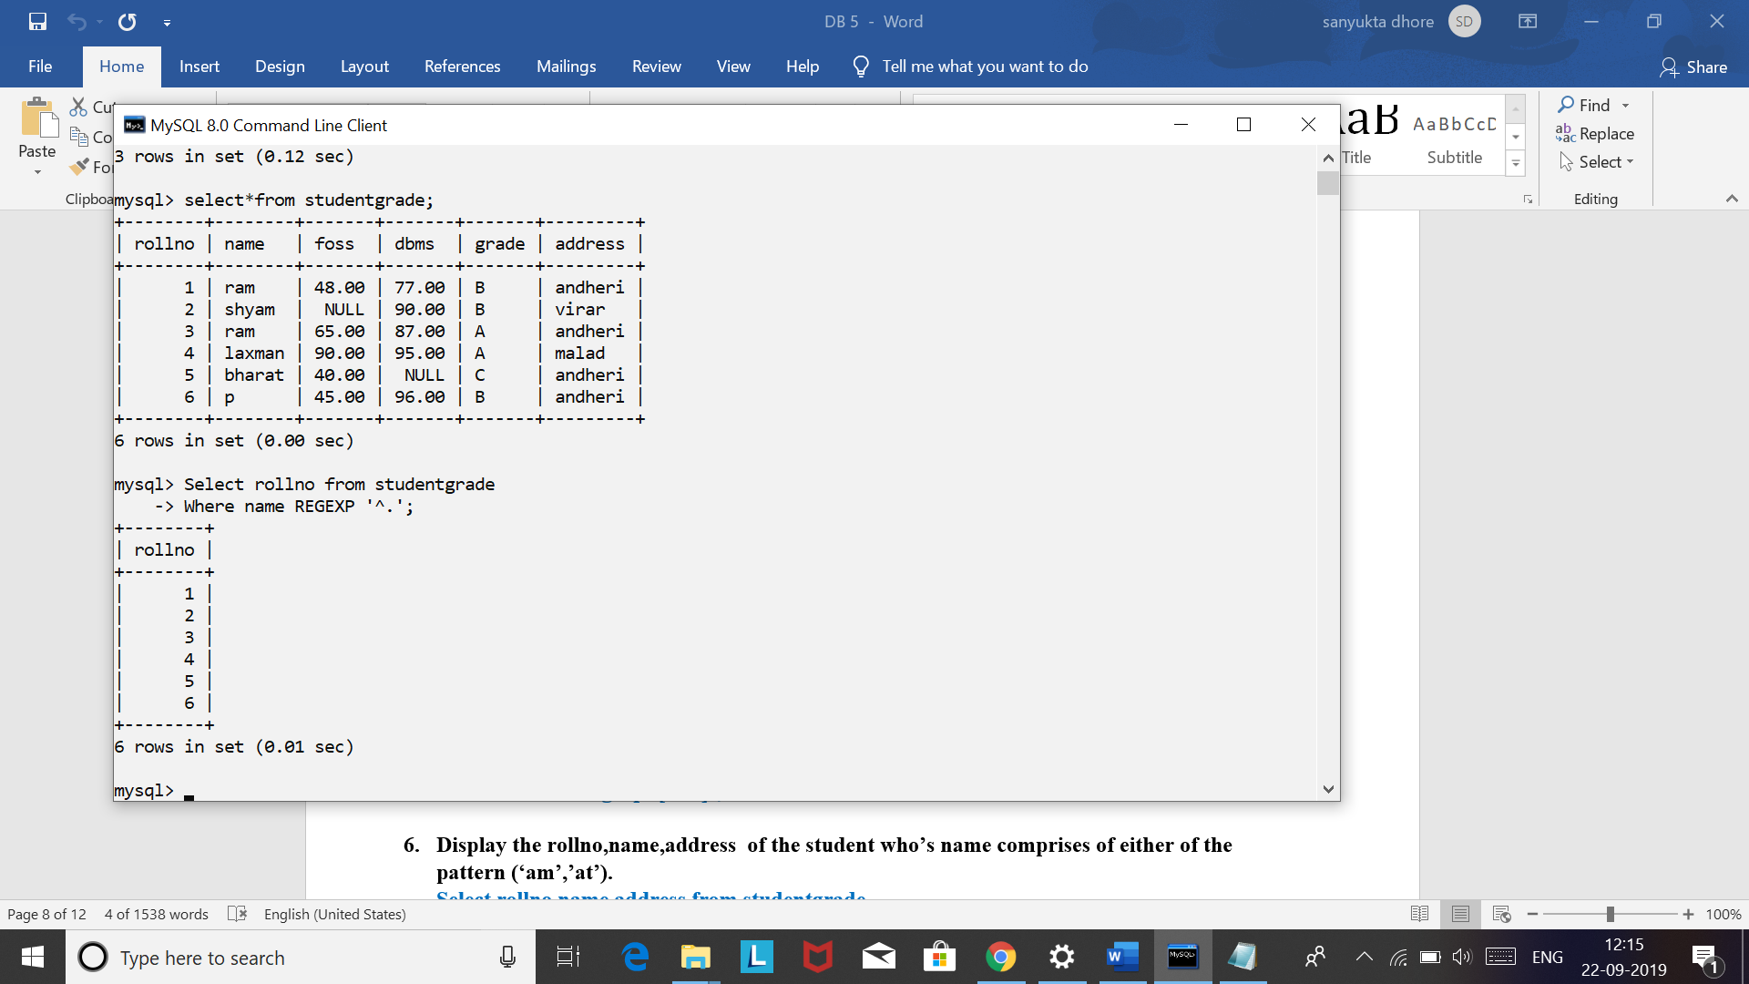

**Select rollno from studentgrade**

**Where name LIKE ‘_’**

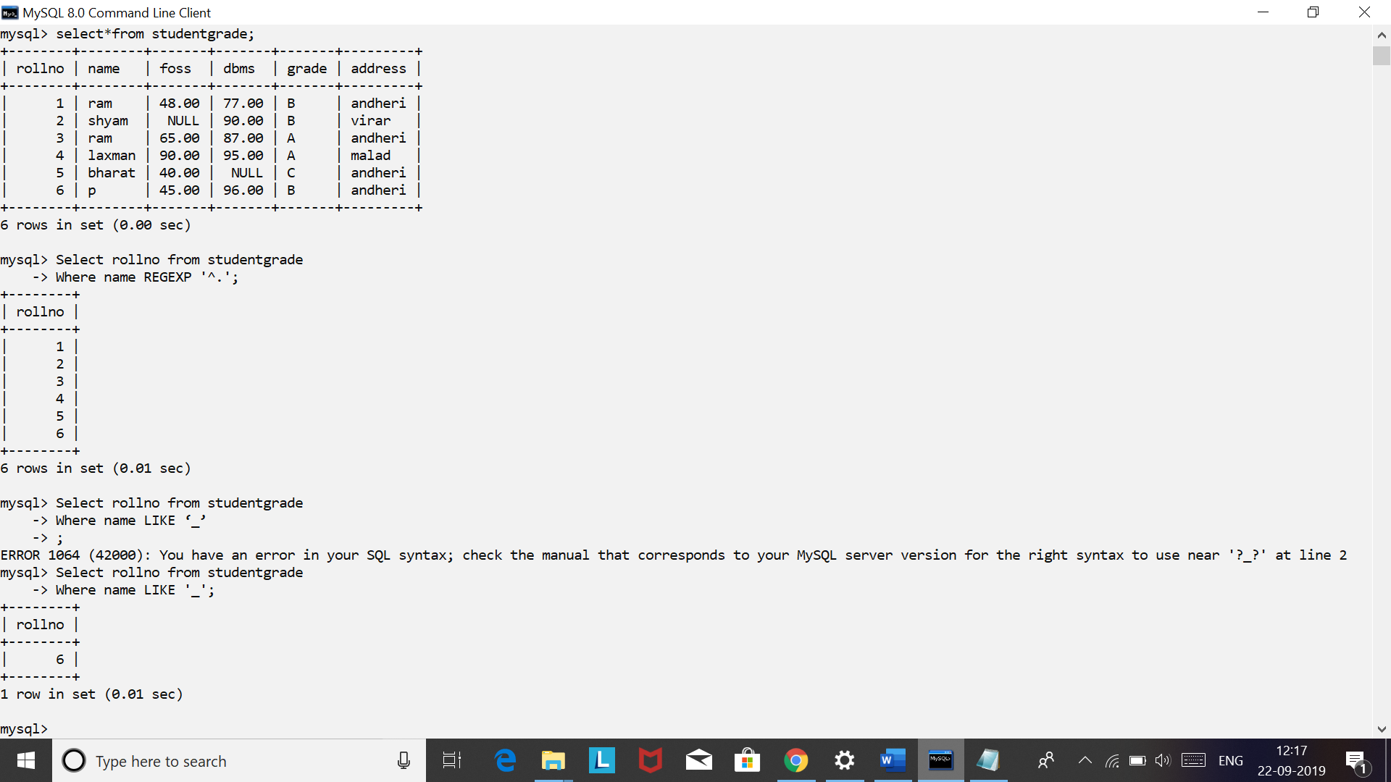

1. **Find the grade,roll,dbms of the student who’s name comprises of any character from list(x,u,v)**

**Select grade,rollno,dbms from studentgrade**

**Where name regexp ‘[xuv]’;**

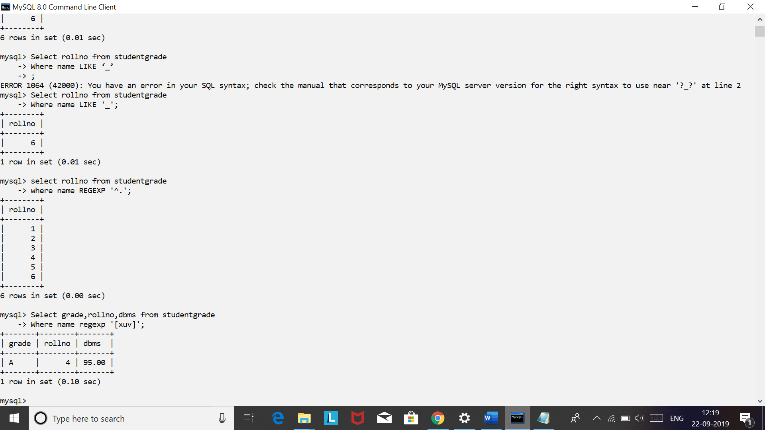

1. **Find the rollno,name of the student who’s address comprises of charactersfrom range [A-P]**

**Select rollno,name from studentgrade**

**Where address regexp ‘[A-P]’;**

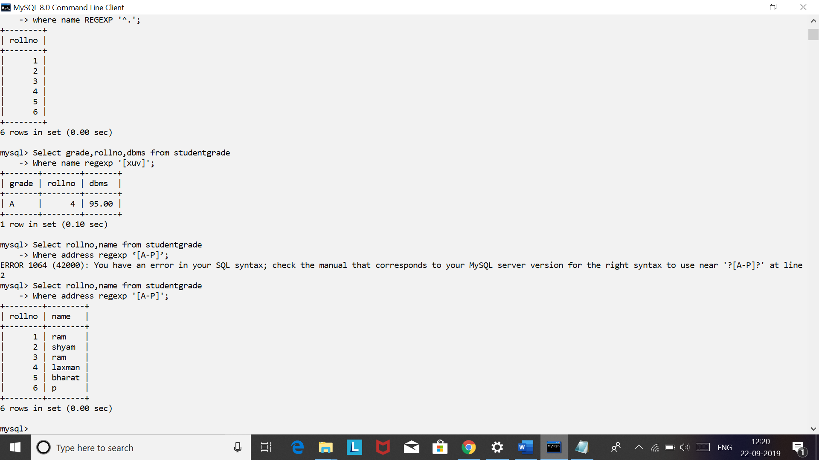

1. **Display the rollno,name,address of the student who’s name comprises of either of the pattern (‘am’,’at’).**

**Select rollno,name,address from studentgrade**

**Where name regexp ‘[am|at]’;**

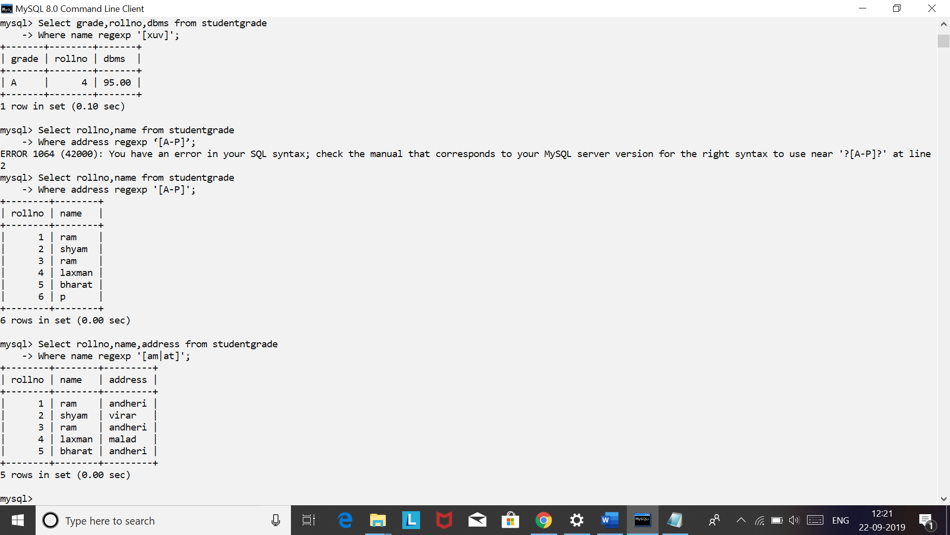

**Student grade:**

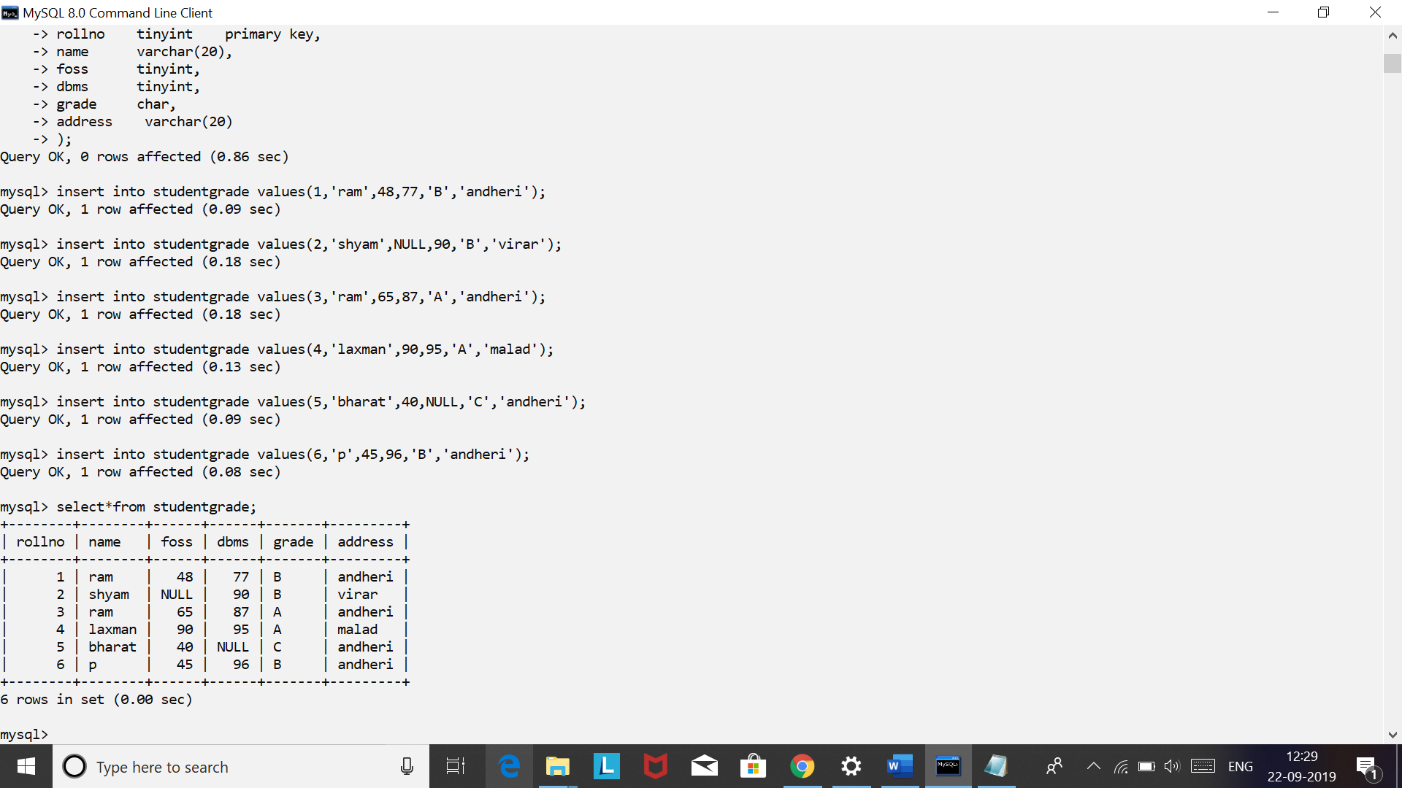

**Solve the following queries using Aggregate functions:**

1. **Return the total number of students in StudentGrade table**

**Select count(*) AS Totalstudents from studentgrade;**

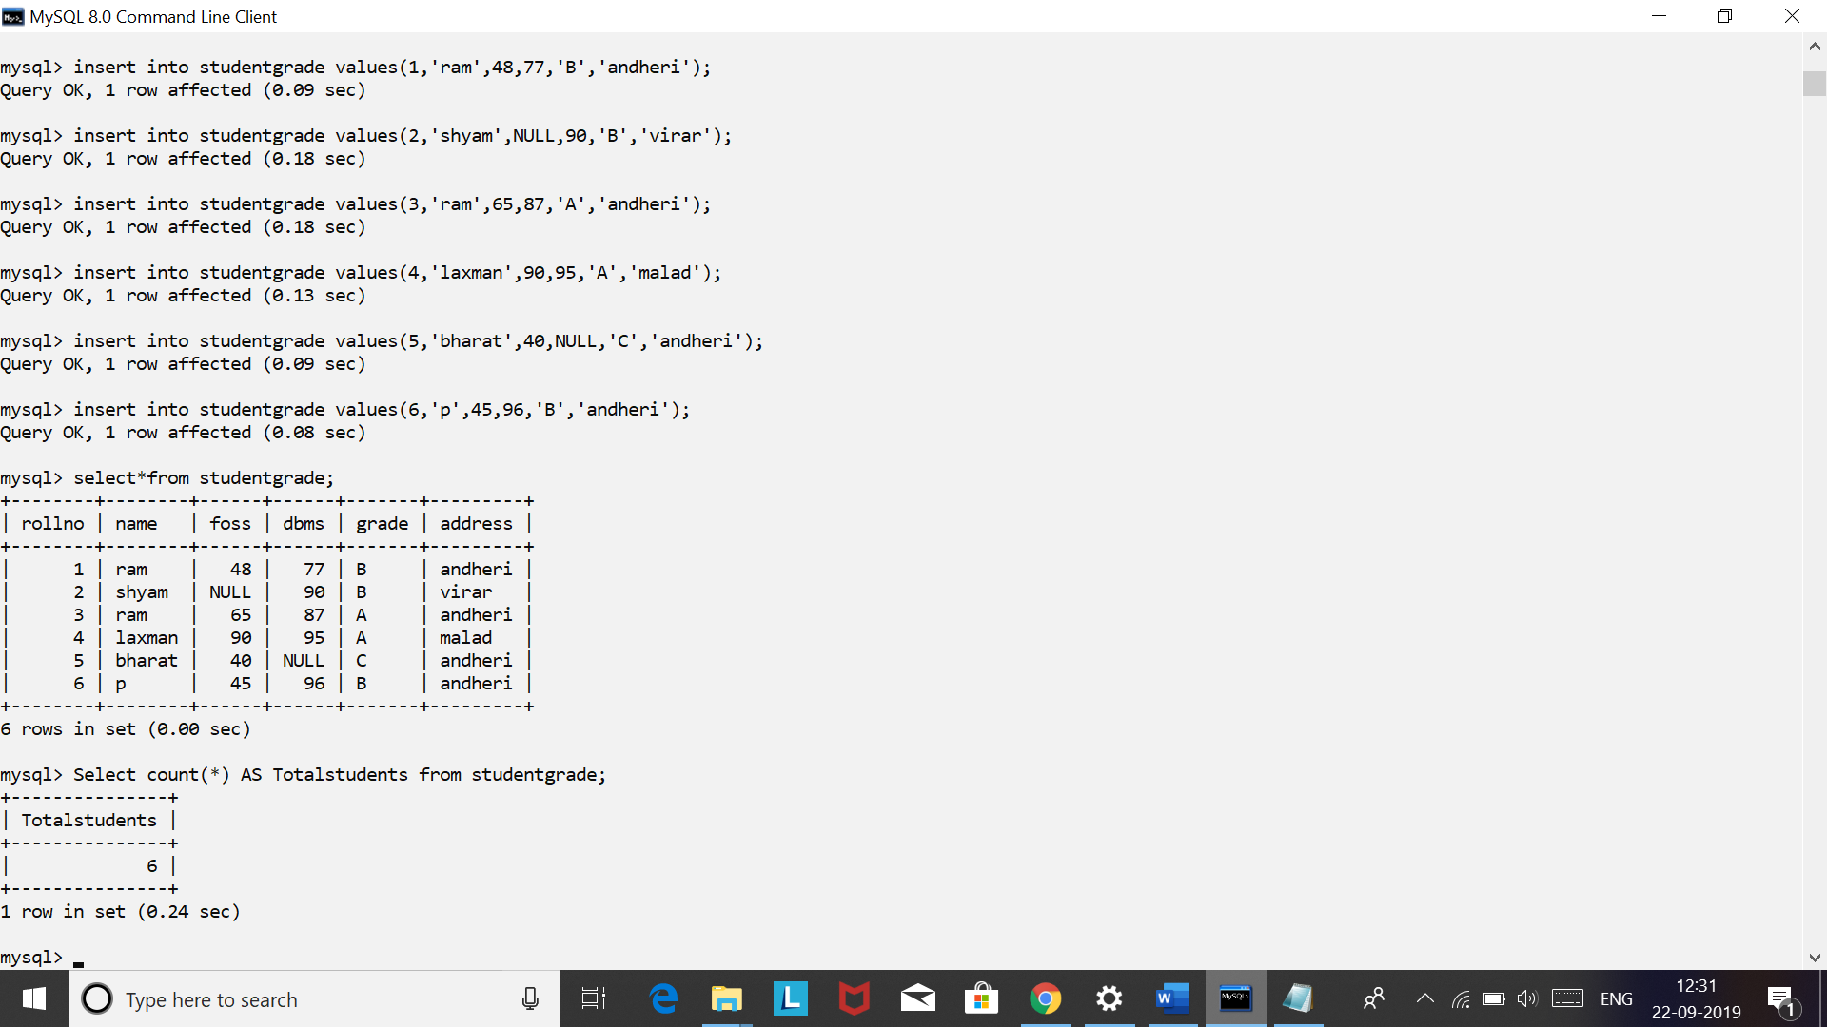

1. **What is the highest marks scored in dbms subject**

**Select max(dbms) as DBMS_HIGHEST from studentgrade;**

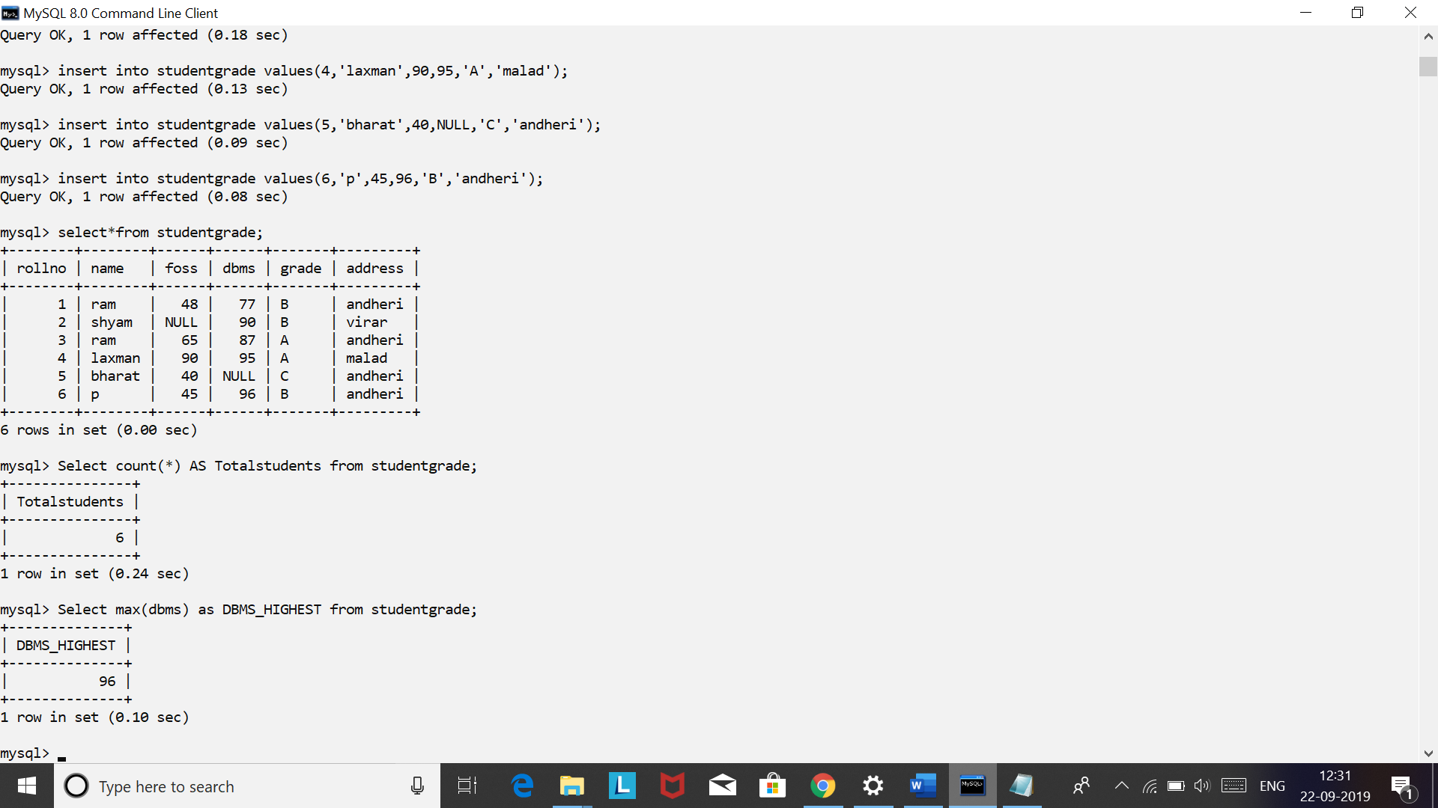

1. **Find the number of students having unique names**

**Select count(name) from studentgrade;**

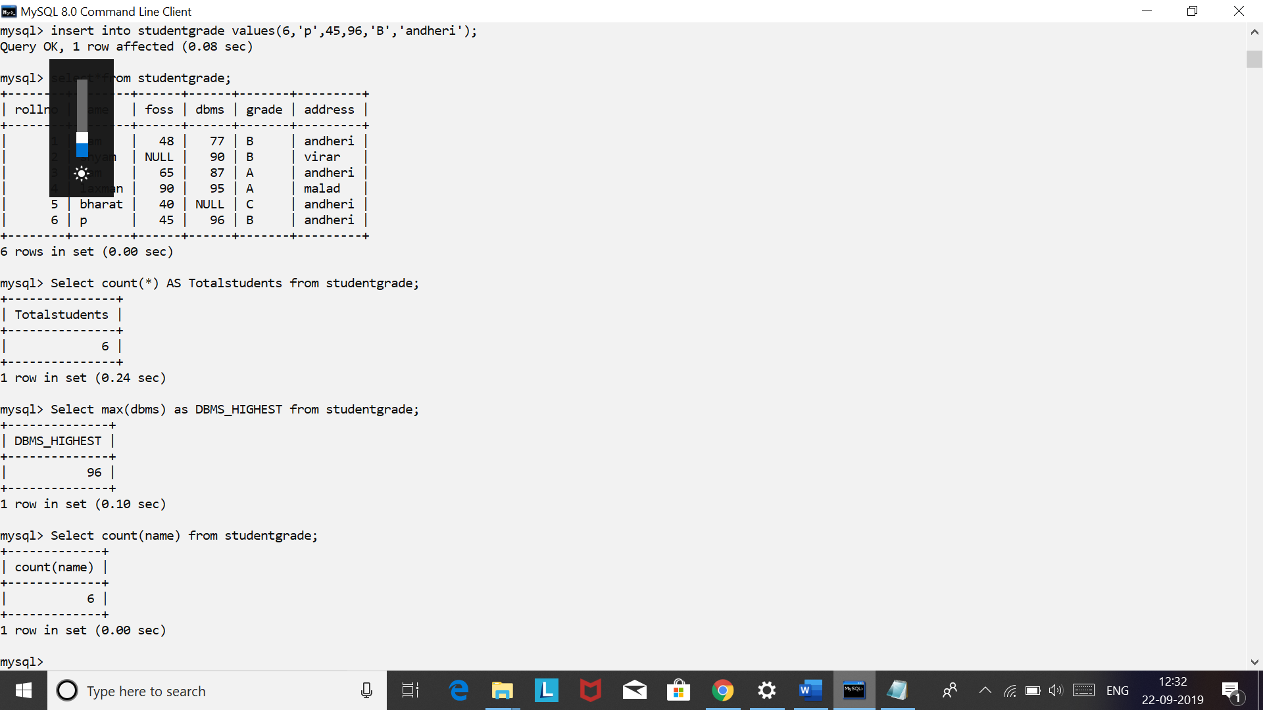

**Select count(distinct name) from studentgrade;**

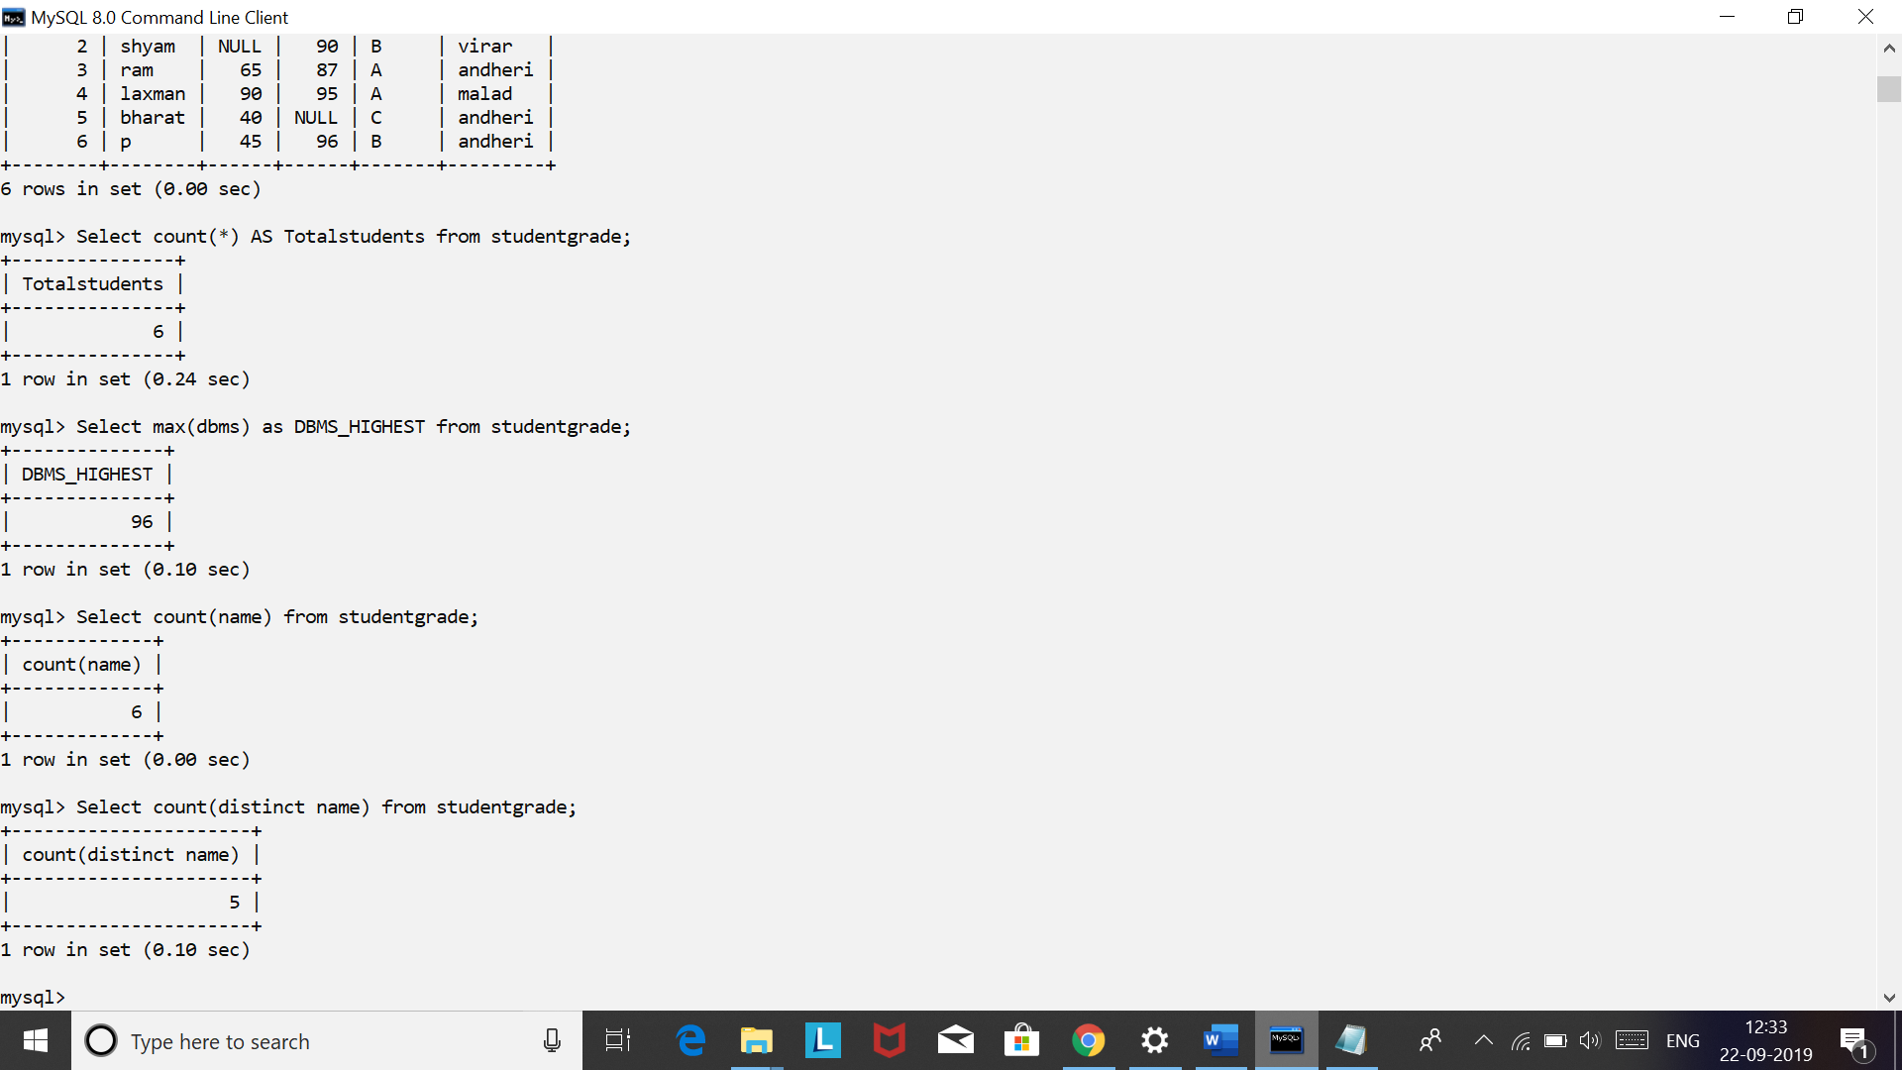

1. **Display the count of students having foss marks as not null.**

**Select count(foss)from studentgrade**

**Where foss is not null;**

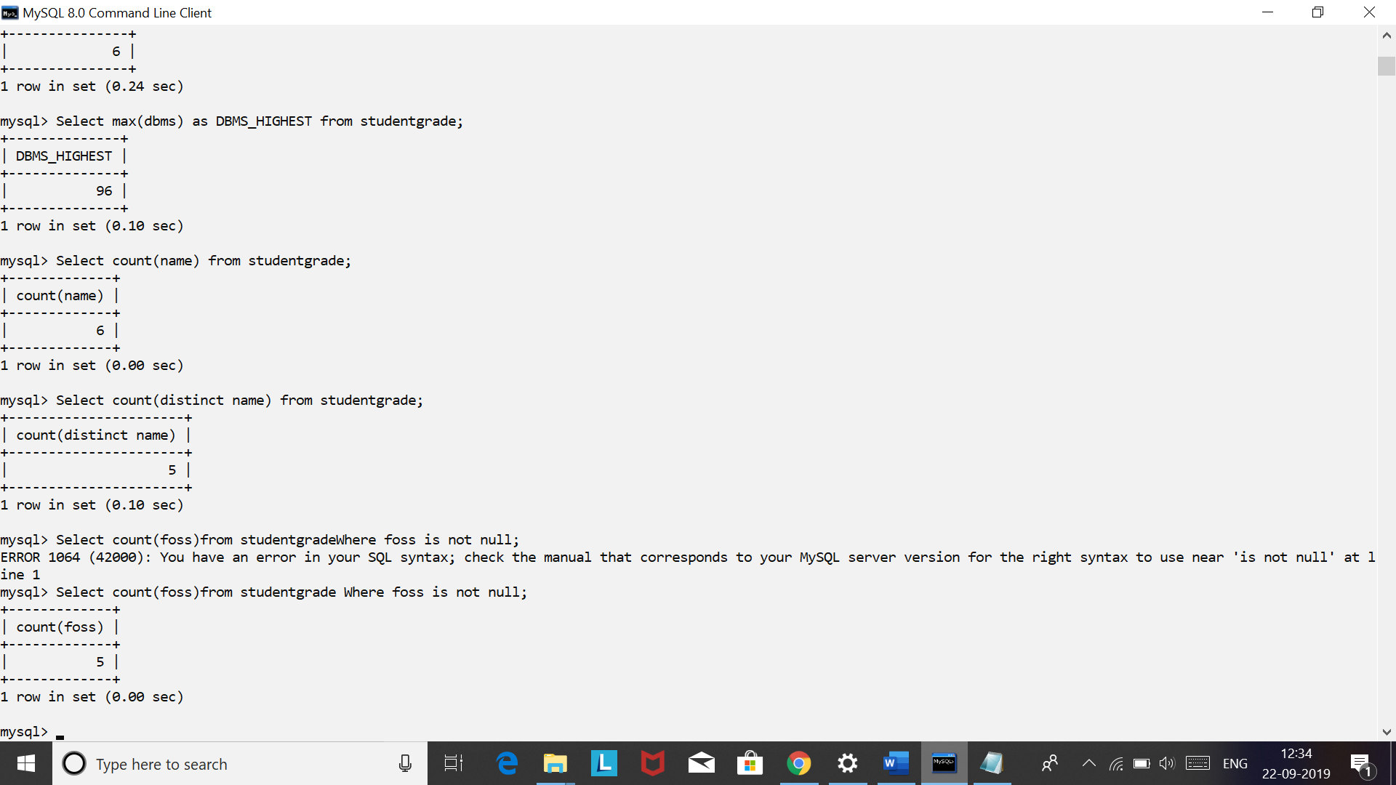

1. **Find the name and grade of student scoring highest marks in foss.**

**Select name,grade from studentgrade**

**Where foss=(select max(foss) from studentgrade)**

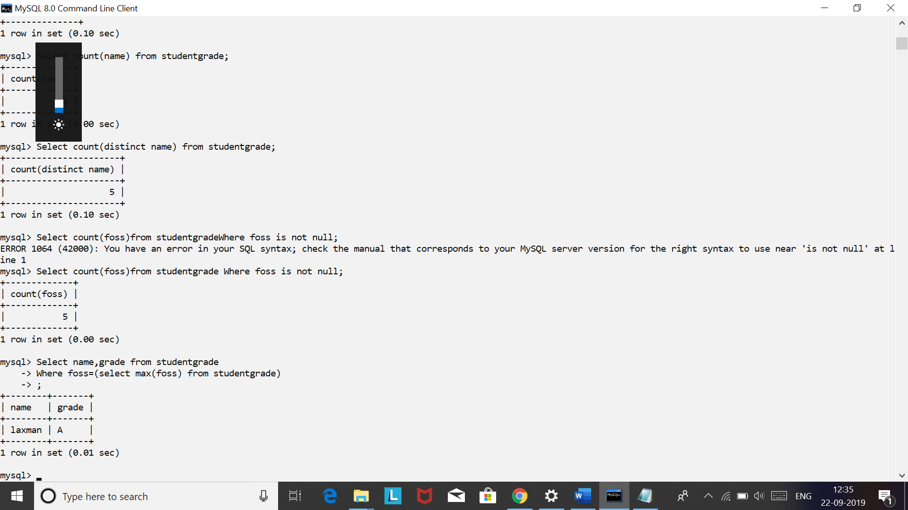

1. **Display total marks scored by all students in dbms**

**Select sum(dbms) from studentgrade;**

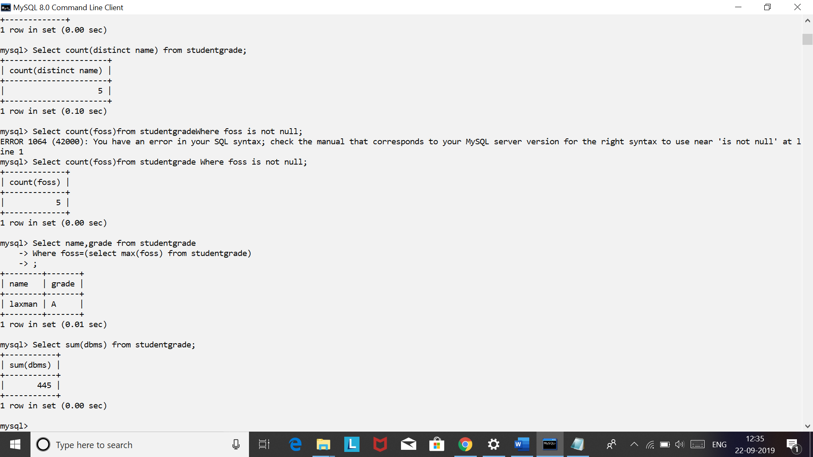

1. **Display minimum marks scored in dbms**

**Select min(dbms) from studentgrade;**

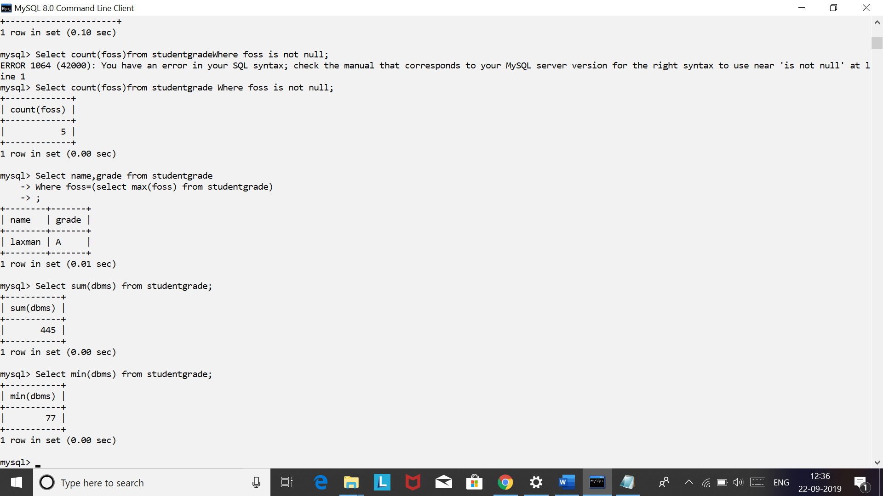

1. **Count the number of students failing in foss subject**

**Select count(*) from studentgrade where foss<40 or foss is NULL;**

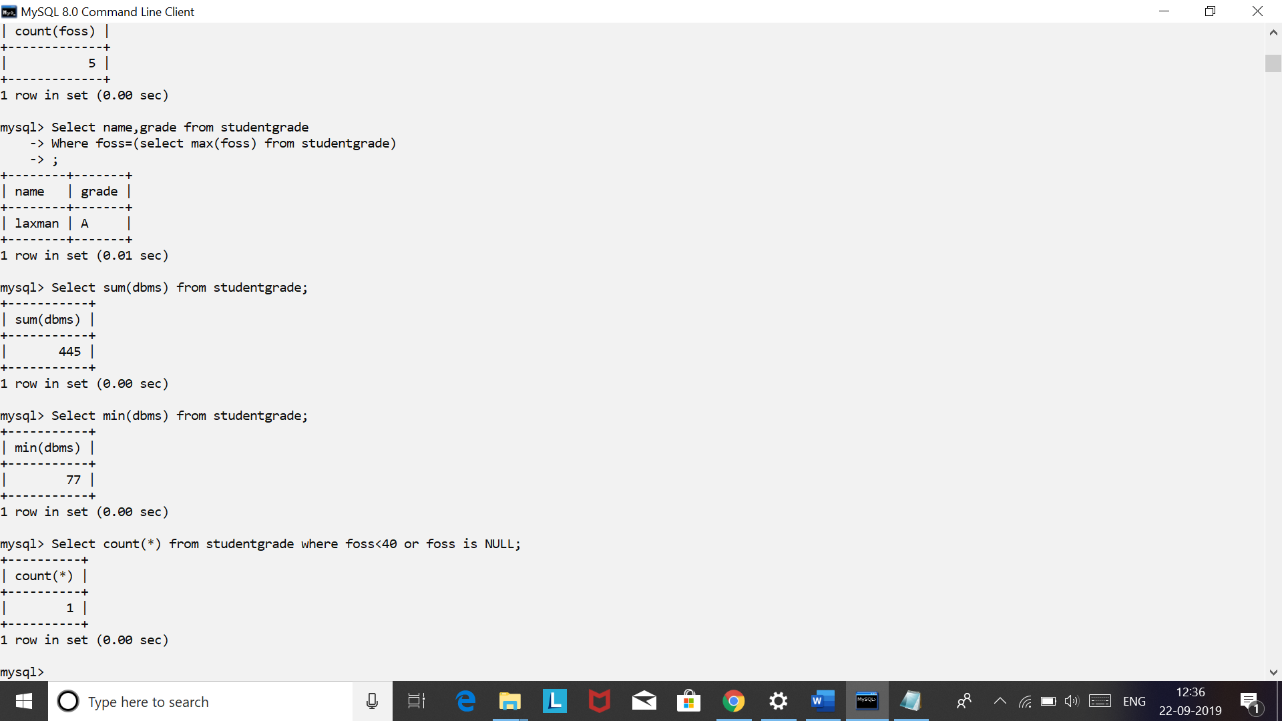

1. **Count the number of students failing in either of foss or dbms subject**

**Select count(*) from studentgrade where foss<40 or foss is NULL or dbms<40 or dbms is NULL;**

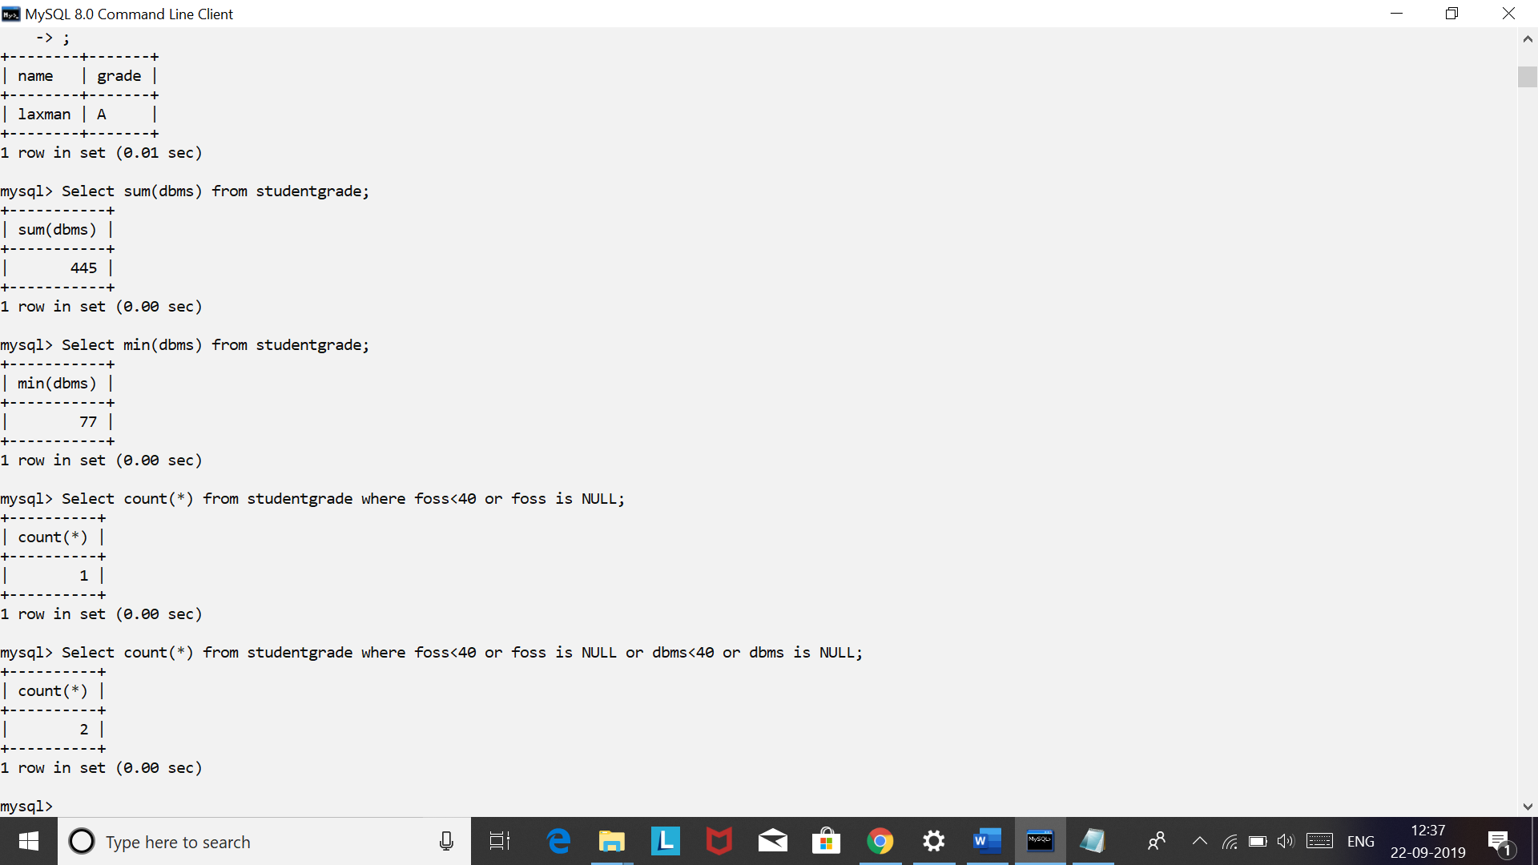

**5.2 Simple Queries with Aggregate functions**

**Solve the following queries using Aggregate functions on StudentGrade table:**

1. **Return the total number of students in StudentGrade table**

**Select count(*) as total from studentgrade ;**

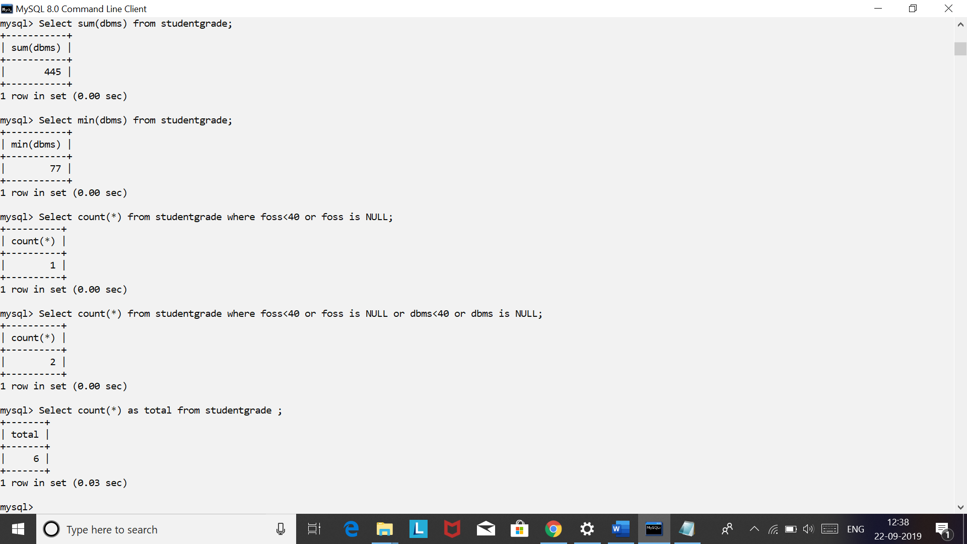

1. **What is the highest marks scored in dbms subject**

**Select max(dbms) as ‘highest in dbms’ from studentgrade ;**

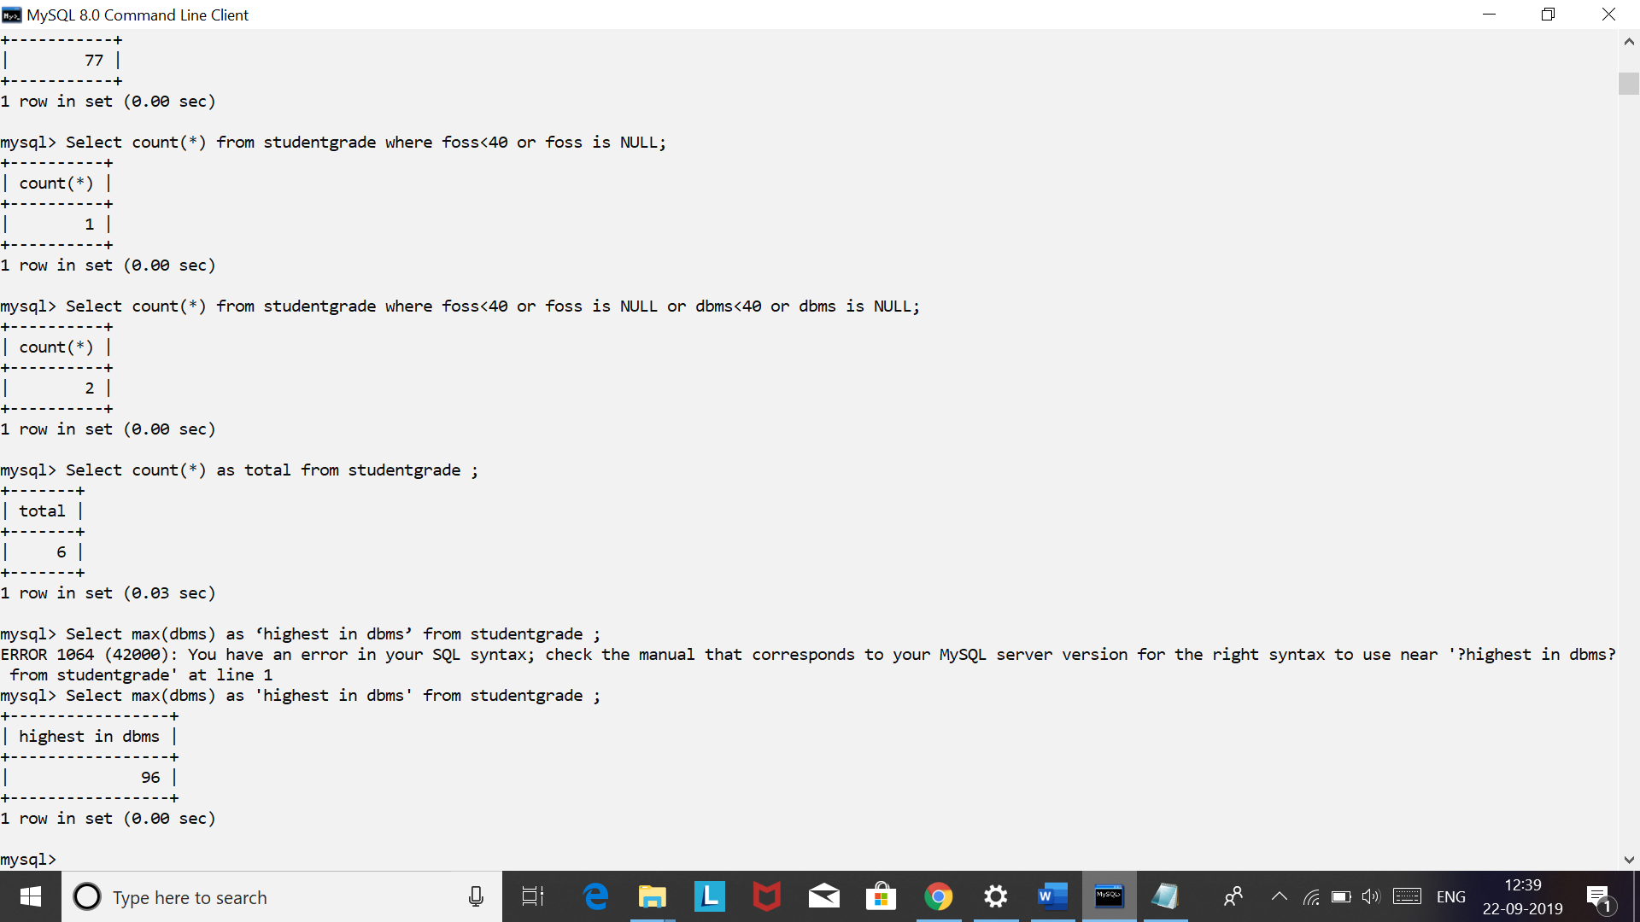

1. **Find the number of students having unique names**

**Select count(distinct name) as ‘count of unique names’ from studentgrade ;**

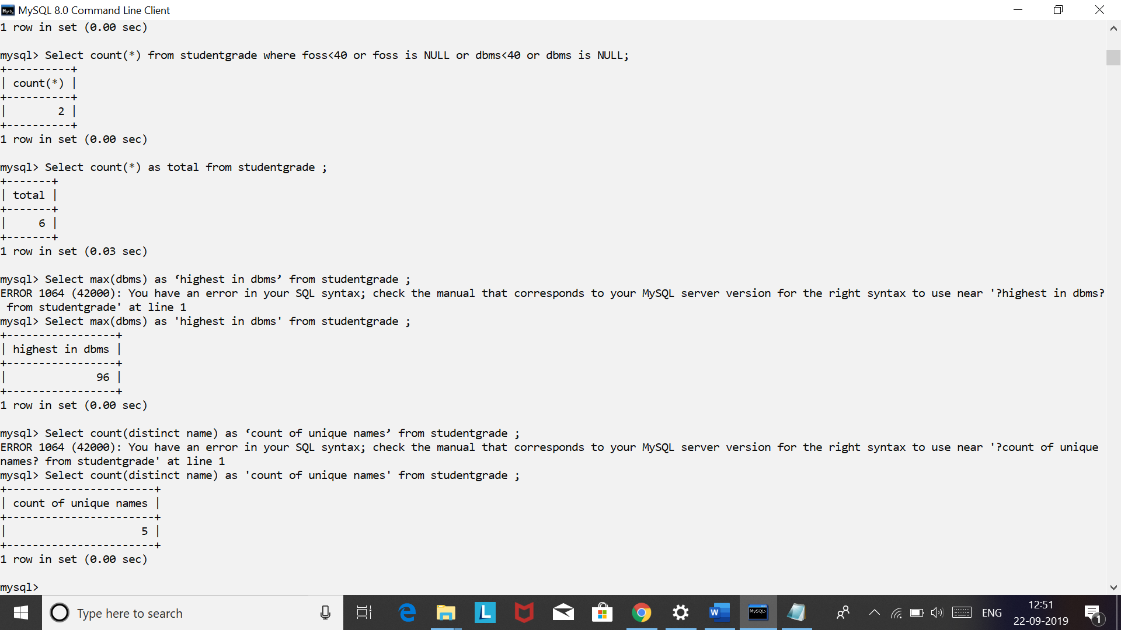

1. **Display the count of students having foss marks as not null.**

**Select count(foss) as foss from studentgrade ;**

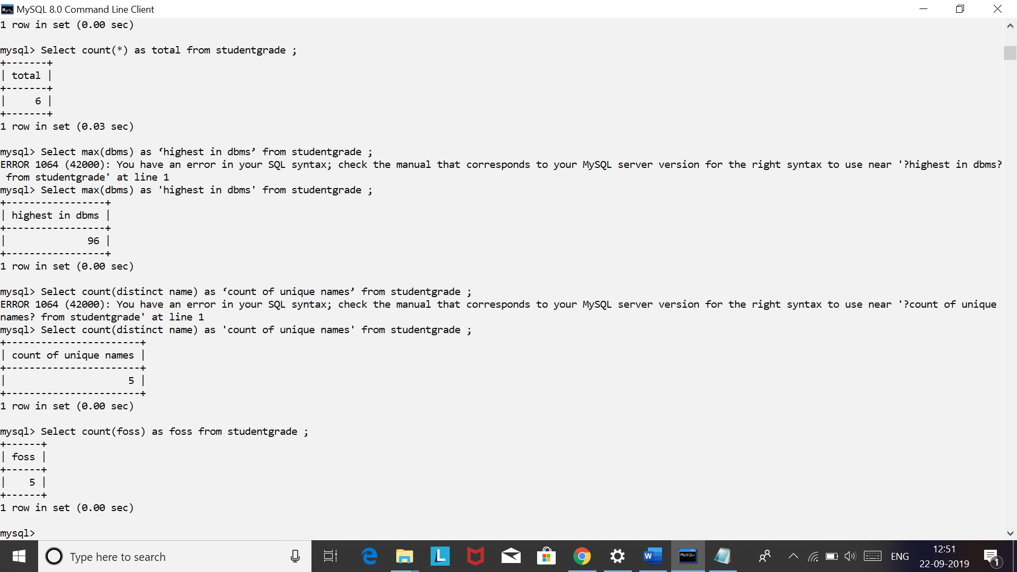

1. **Find the name and grade of student scoring highest marks in foss.**

**select name,grade from studentgrade where foss=(select max(foss) from studentgrade);**

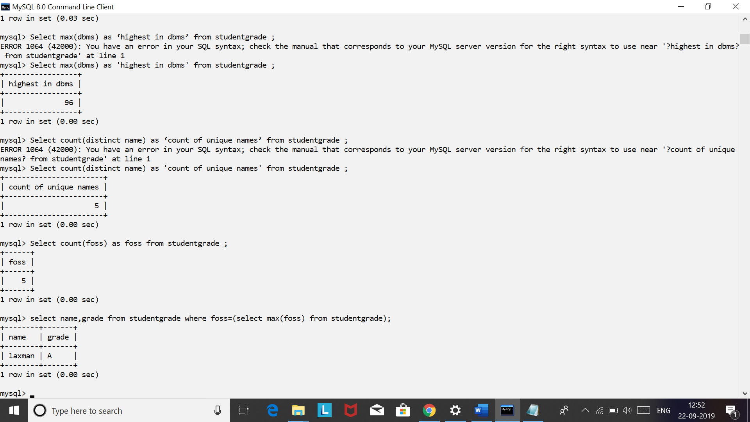

1. **Display total marks scored by all students in dbms**

**Select sum(dbms) from studentgrade ;**

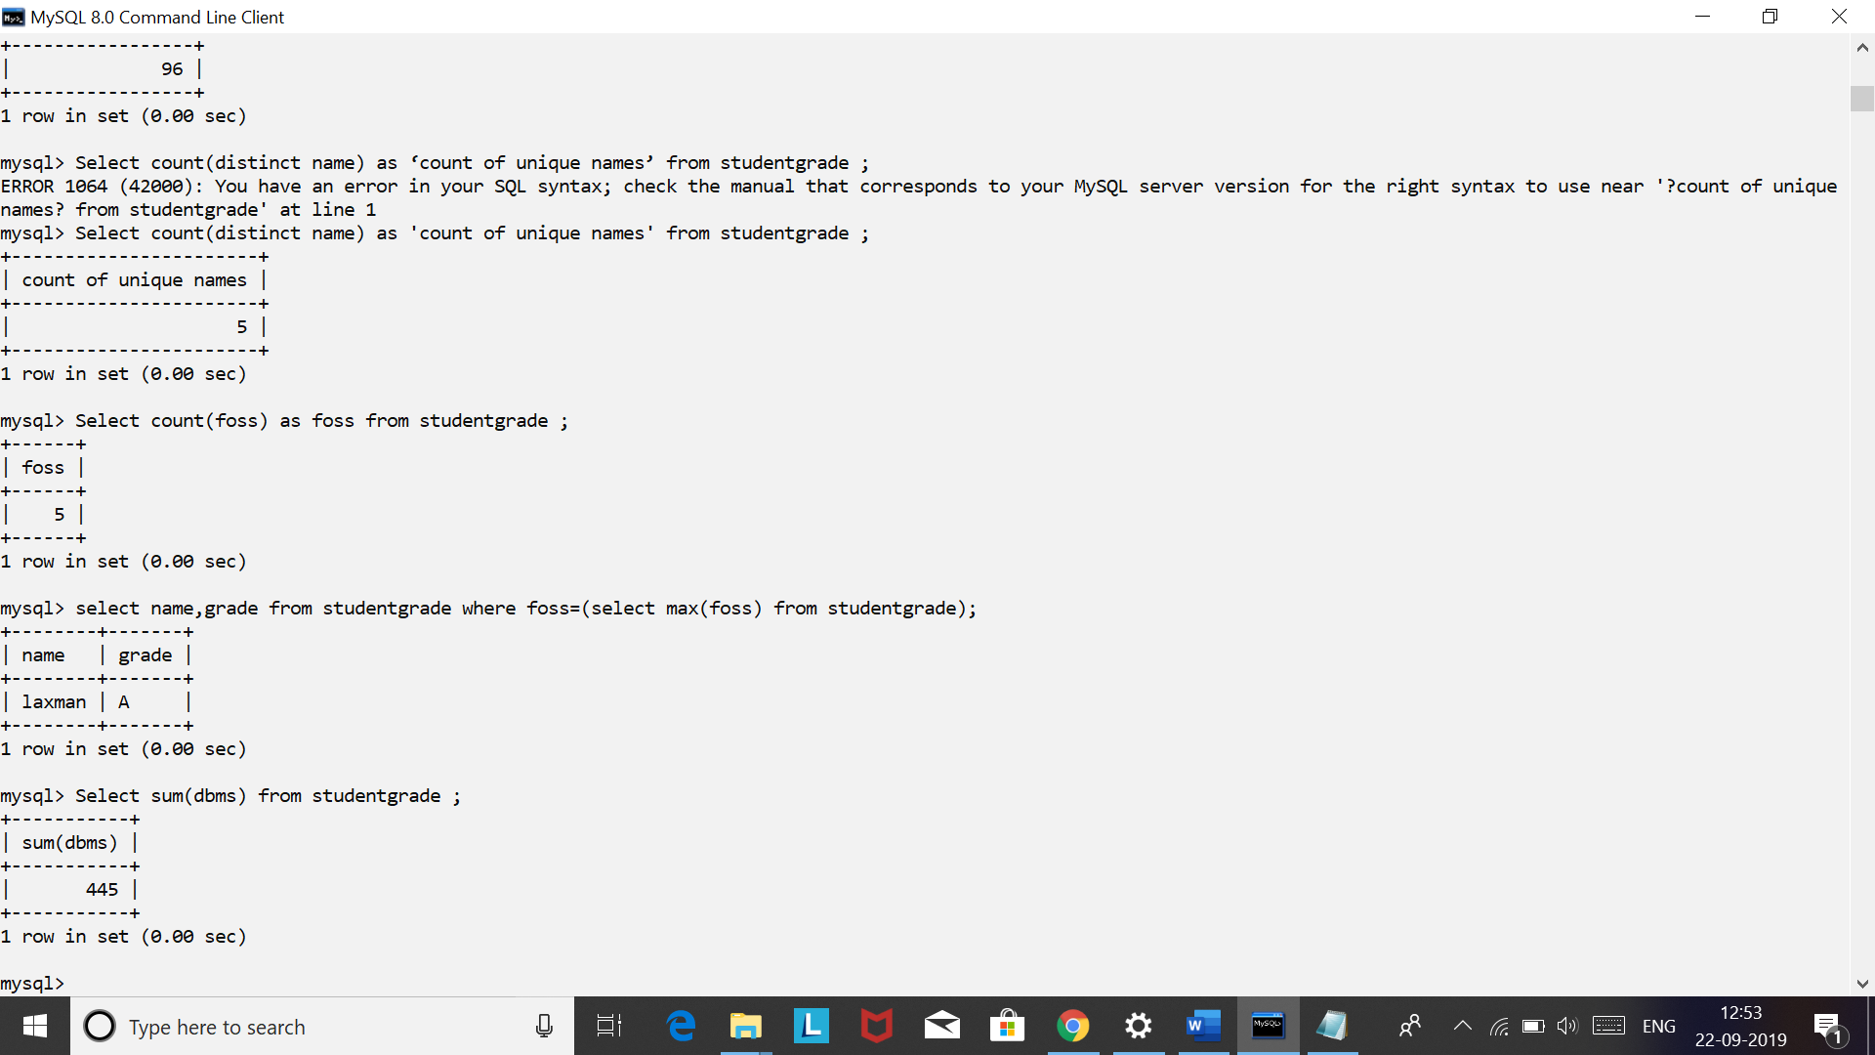

1. **Display minimum marks scored in dbms   
   Select min(dbms) from studentgrade ;**



1. **Display maximum marks scored in dbms**

**Select max(dbms) from studentgrade ;**

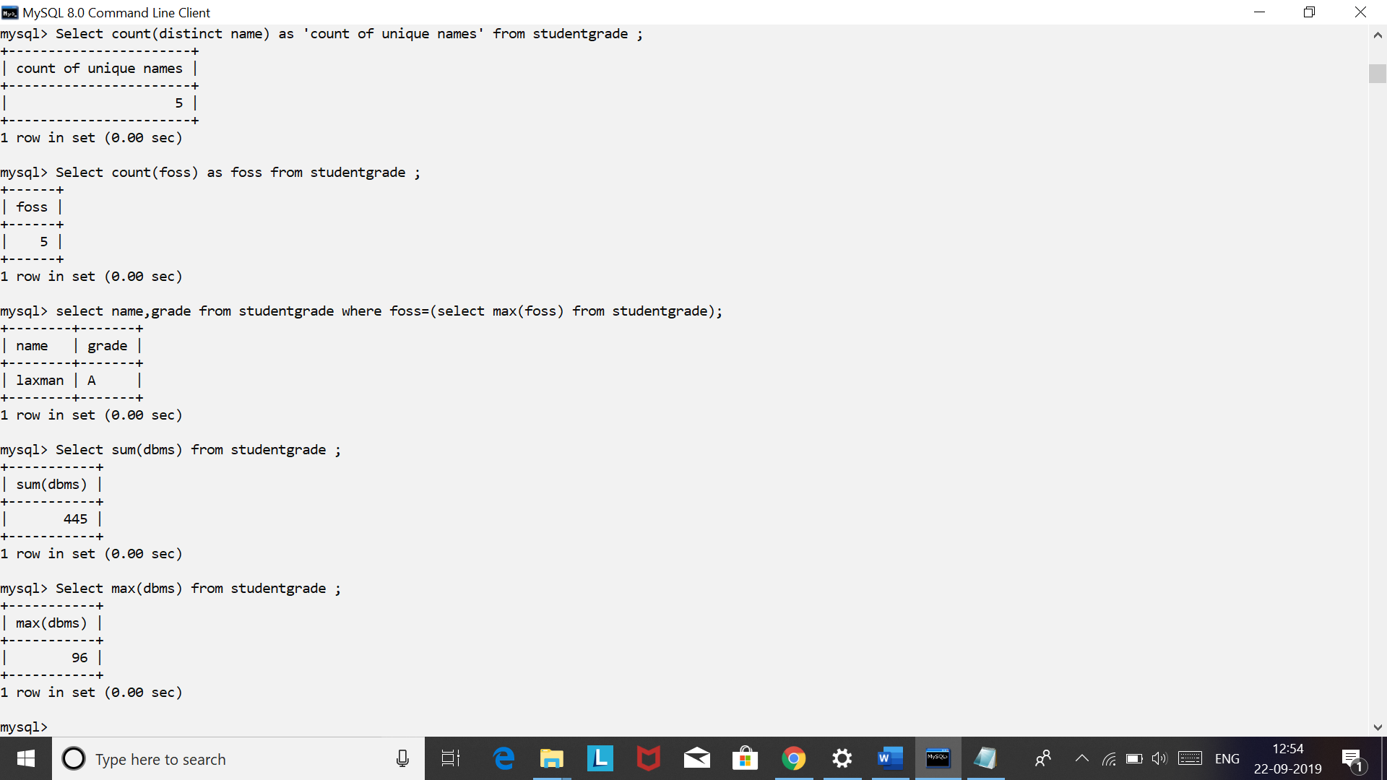 **5.3 Queries with Aggregate functions (group by and having clause)**

**5.3.1 Solve the following queries using group by and having clauses on StudentGrade table:**

1. **Find the number of students for each grade level**

**Select grade,count(*) as count**

**From studentgrade**

**Group by grade;**

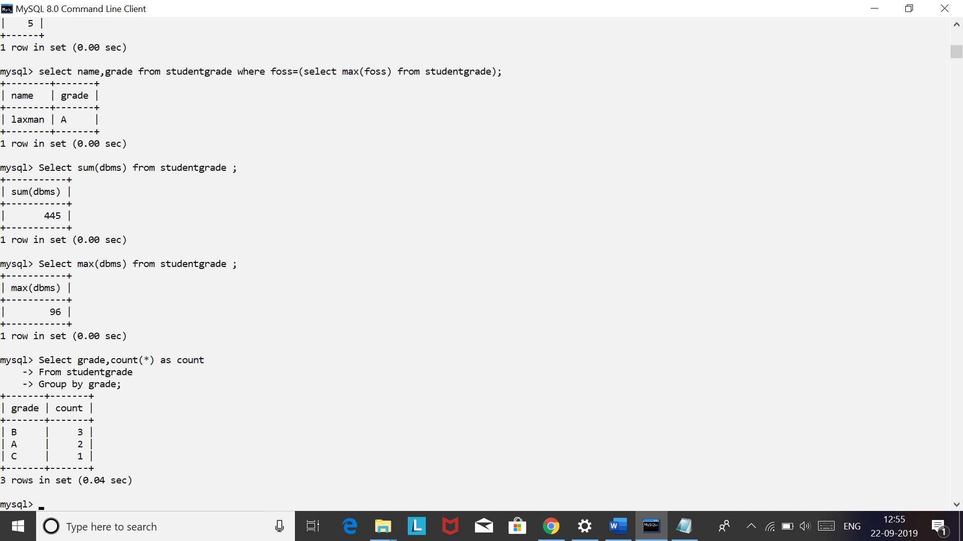

1. **For each grade level find the average marks in dbms**

**Select grade, avg(dbms) as ‘average in dbms’**

**From studentgrade**

**Group by grade;**

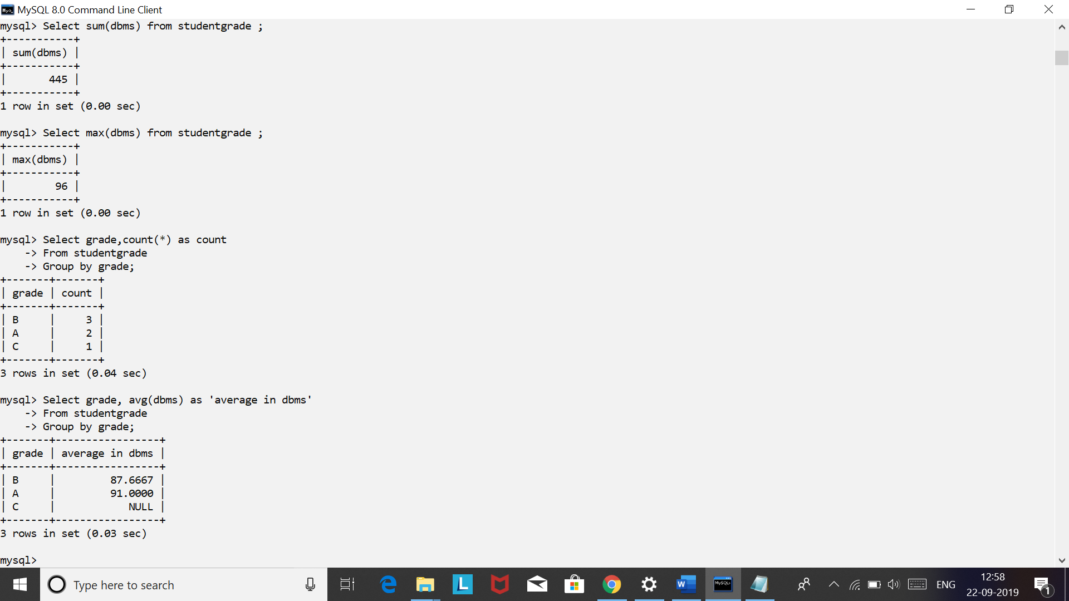

1. **Find the name,rollno of the student at each grade level having highest marks in foss.**

**Select name,rollno from studentgrade**

**Where foss IN(select max(foss) from studentgrade Group by grade);**

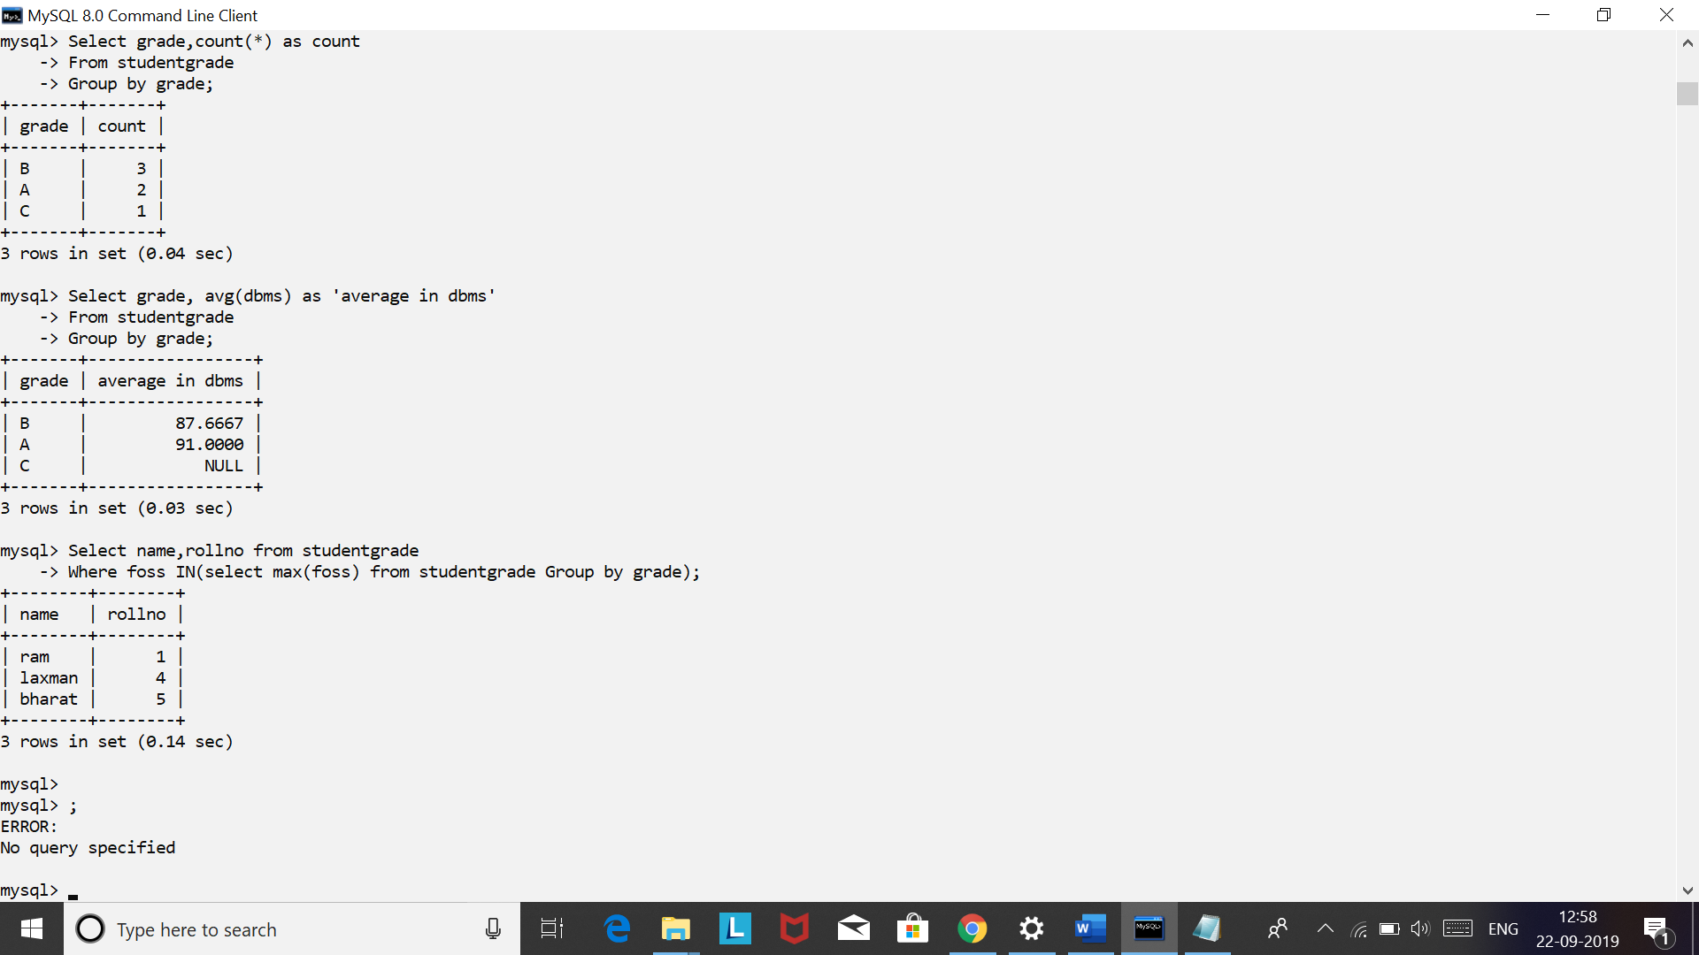

1. **Display the highest percentage scored by the student in each grade level, along with the student name and rollno**

**Select rollno,name,grade,(foss+dbms)/2 as Percentage**

**From studentgrade;**

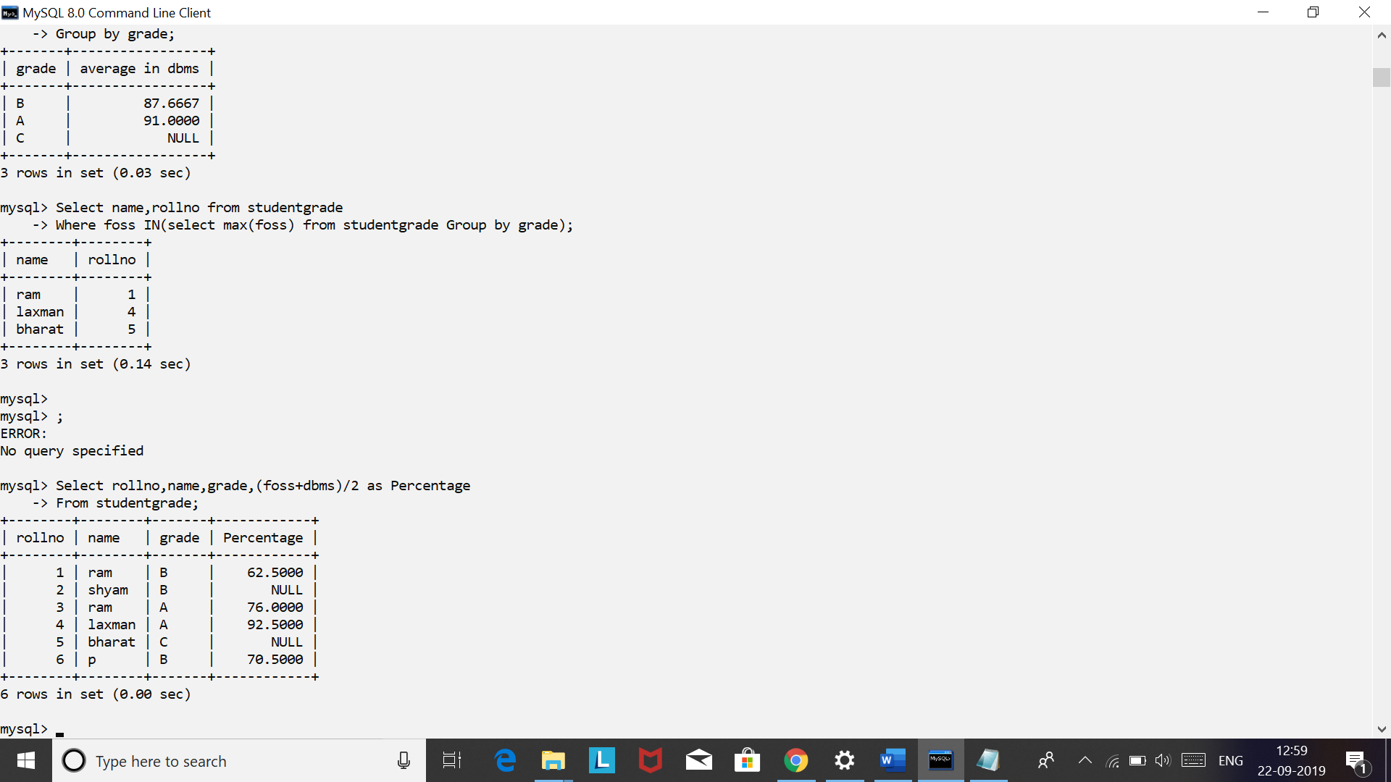

1. **Display the number of student for each grade level scoring minimum 85 marks in dbms.**

**Select count(*),grade from studentgrade**

**Where dbms>=85**

**Group by grade;**

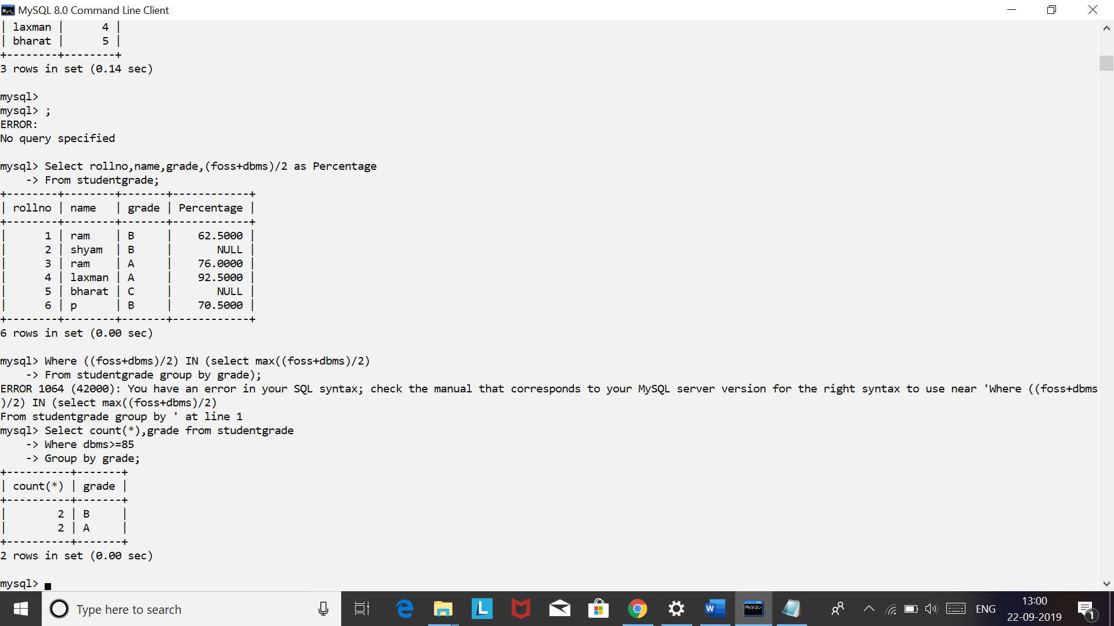

* + 1. **Solve the following queries on Sailors, Boats and reserves table:**

Create the below tables and insert the given records:

BOATS:

BID BNAME COLOR

------ ------------------------- ----------

11 ABC red

12 PQR yellow

13 ZMR green

14 MRF black

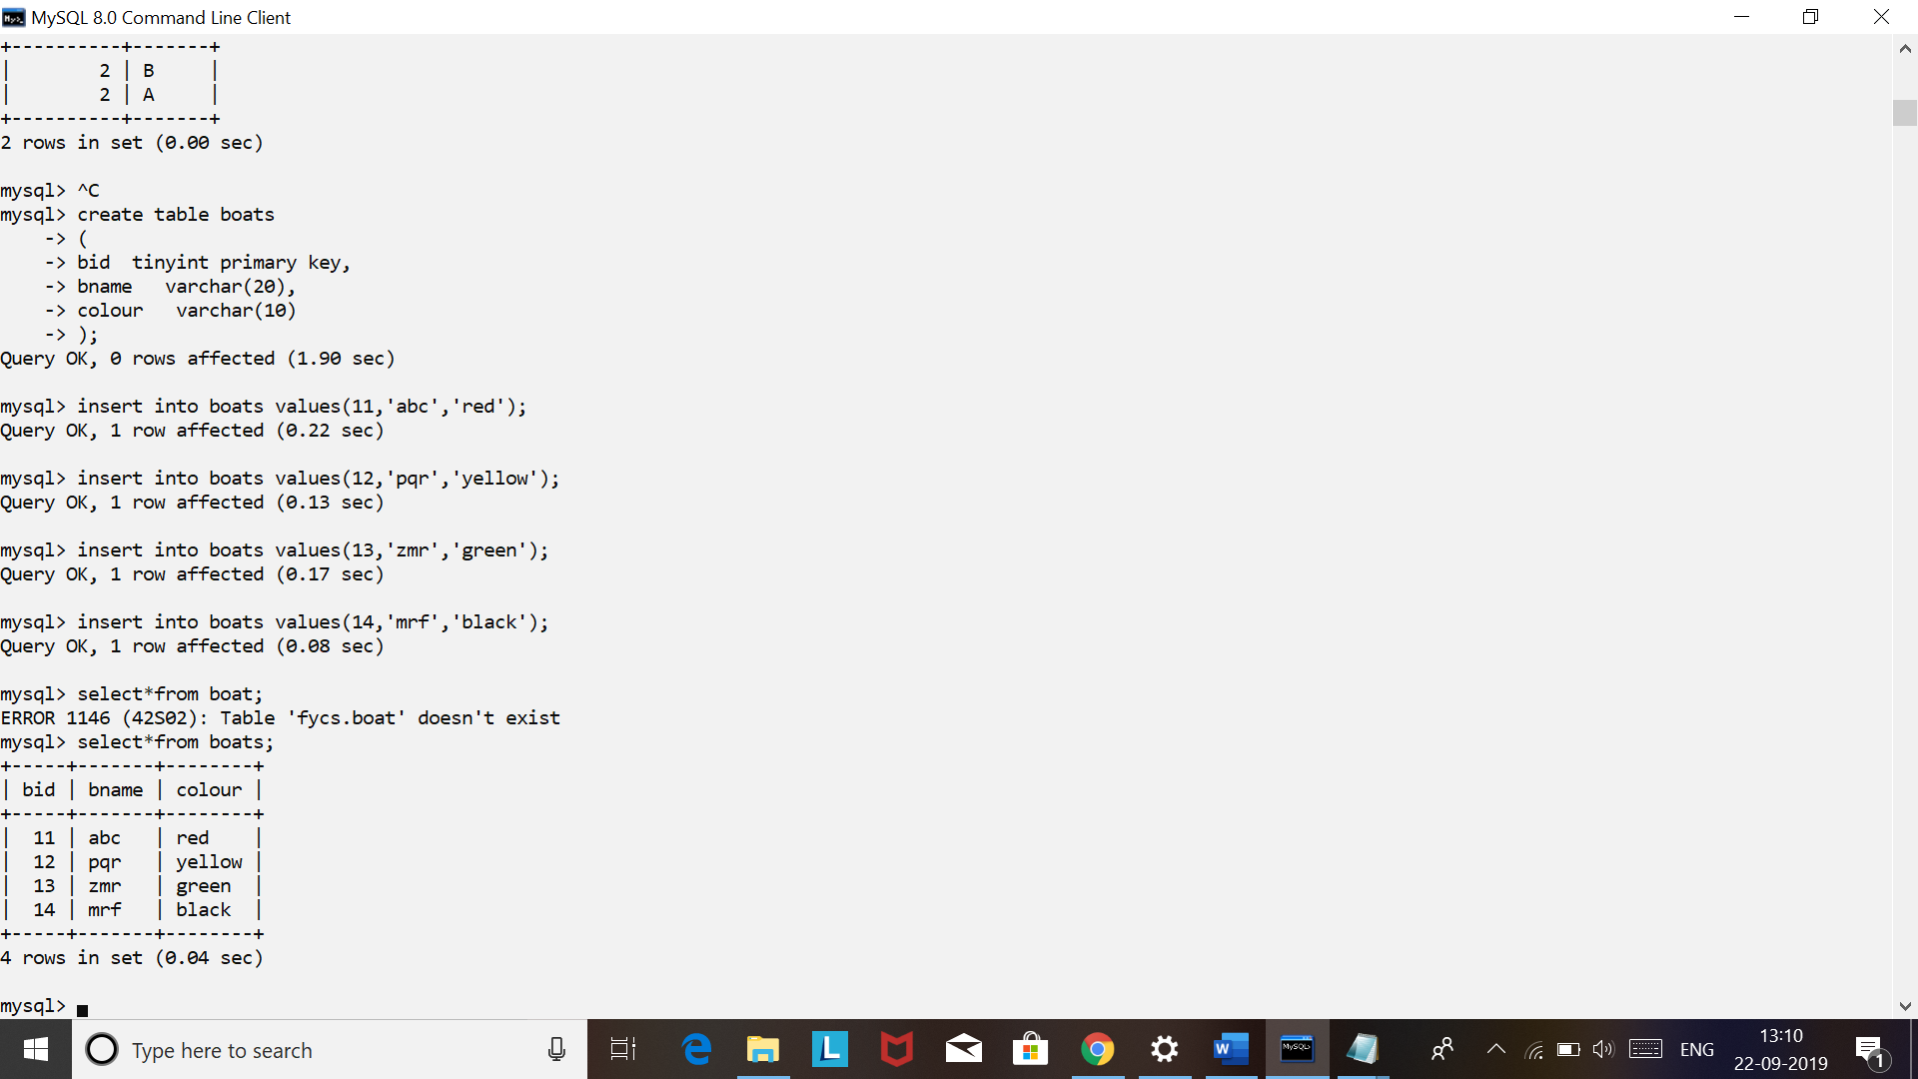

SAILORS:

SID SNAME RATING AGE

------ ------------------------- ---------- ----------

1 prathamesh 8 18

2 rohit 9 19

3 adams 10 19

4 deb 6 20

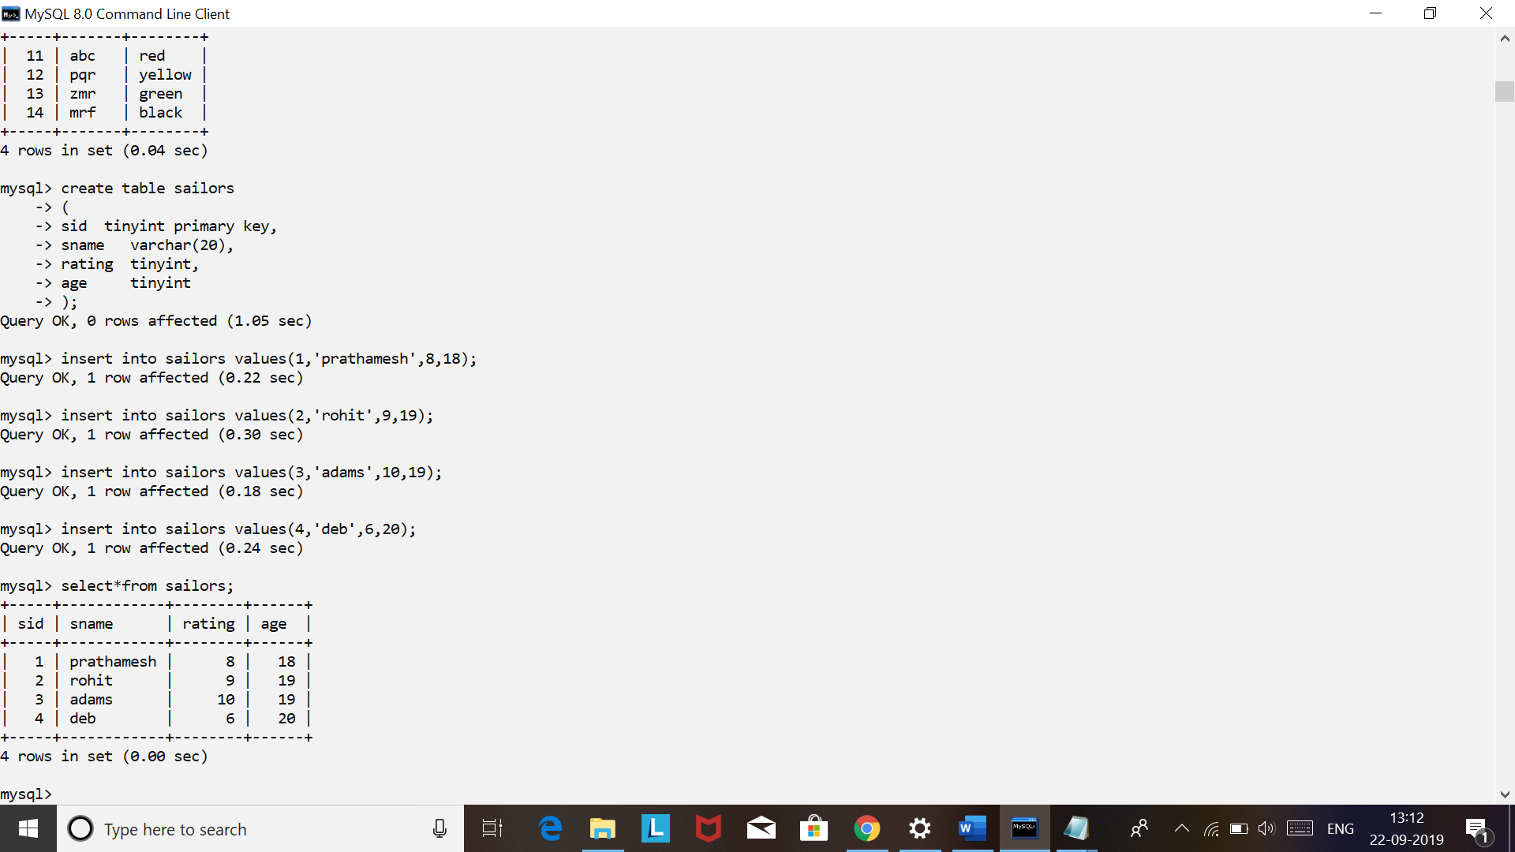

RESERVES:

SID BID DAY

------ ---------- ----------

1 11 wednesday

2 12 thursday

3 13 friday

4 14 Saturday

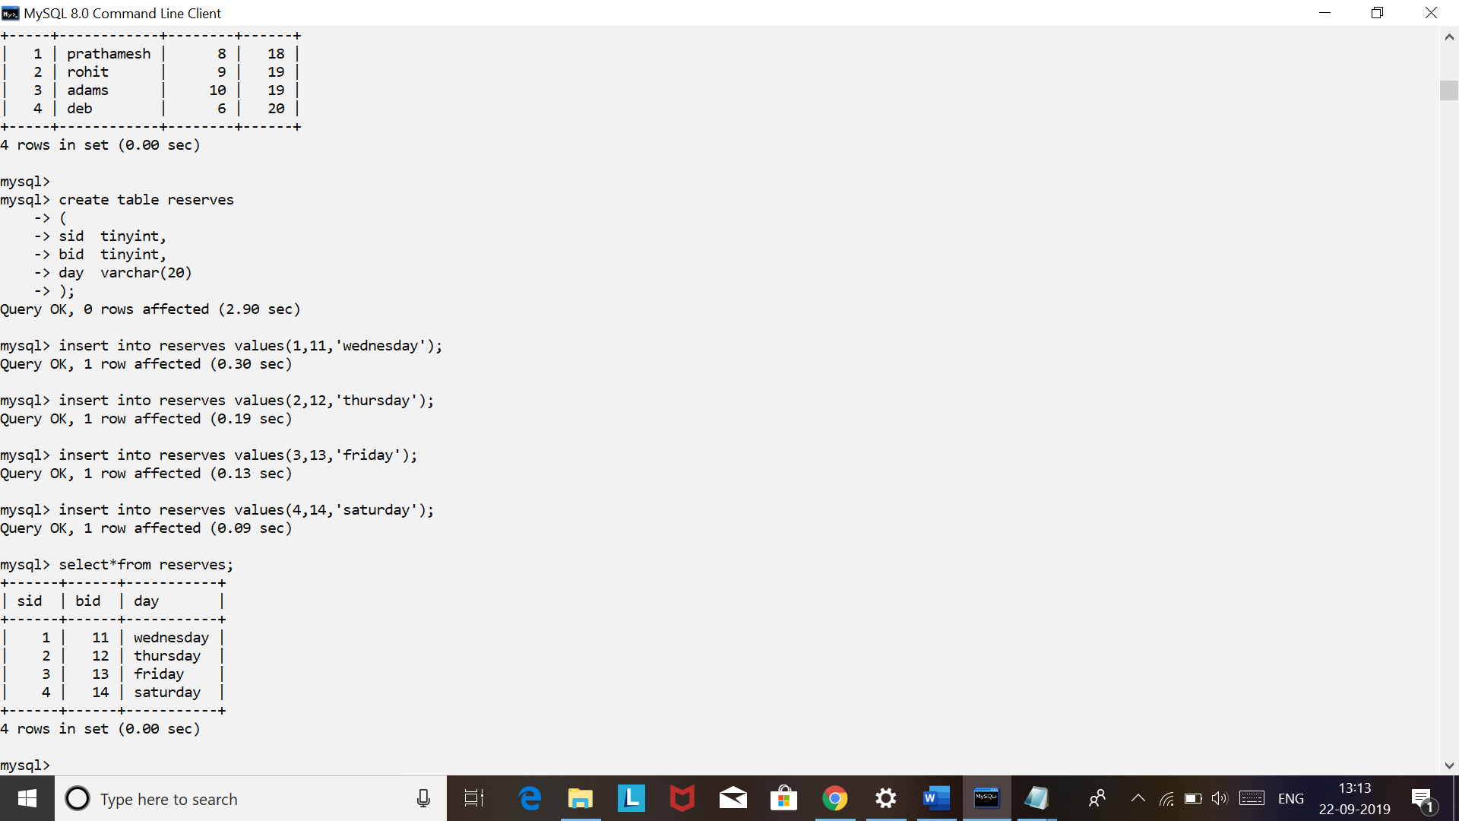

1. **Find the average age of all sailor.**

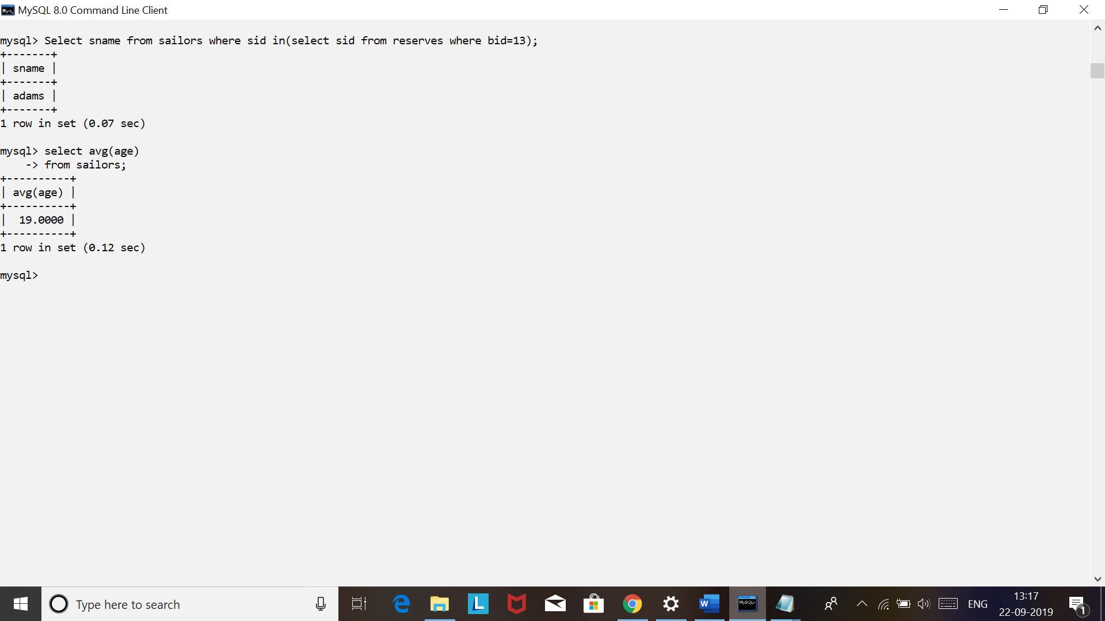

1. **Find the average age of sailor with the rating of 8.**

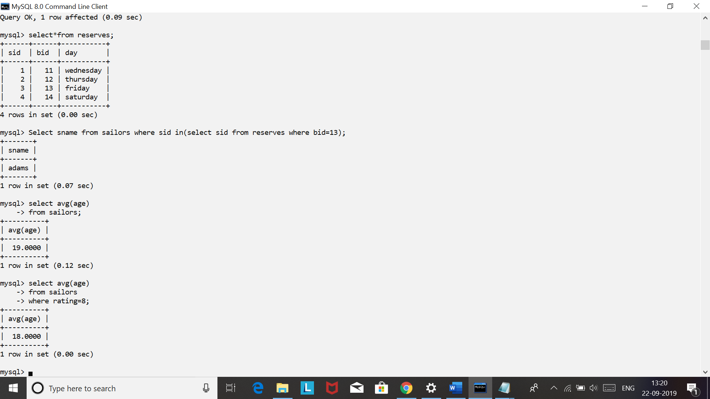

1. **Find the age of the oldest sailor.**

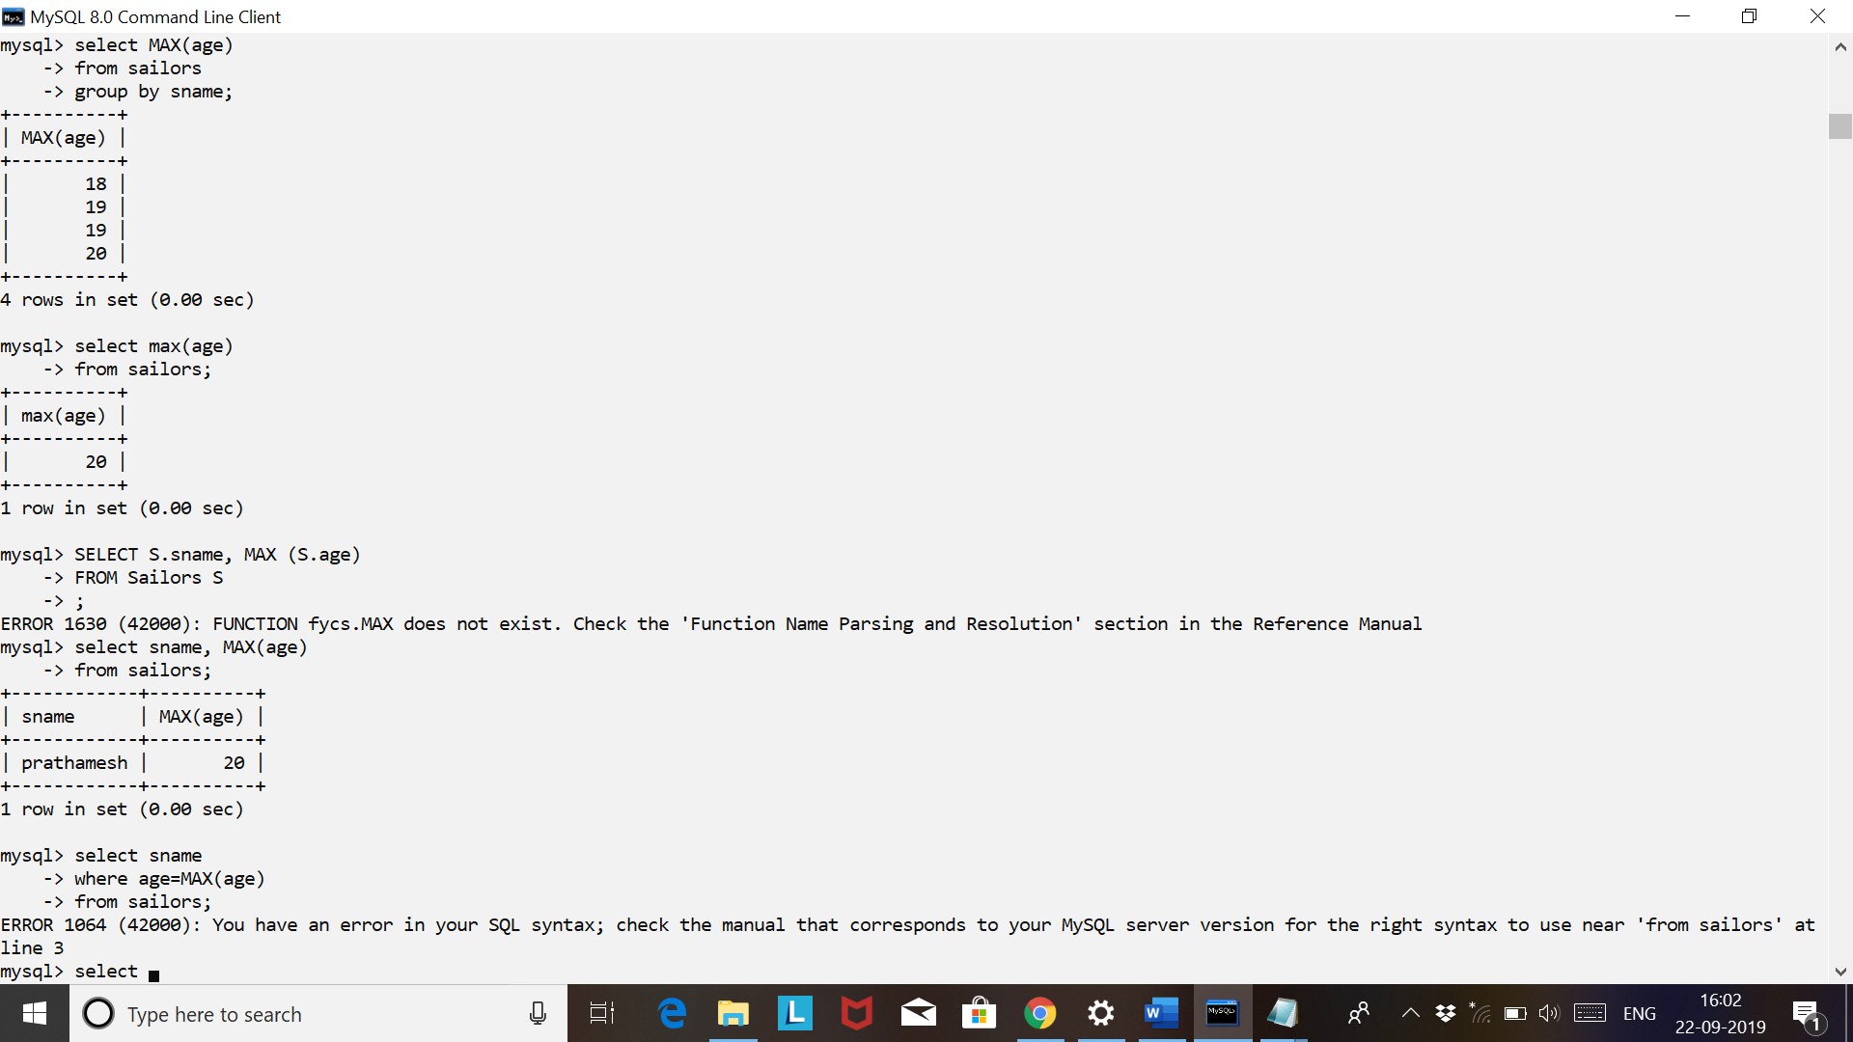

1. **Count the number of records in sailor table.**

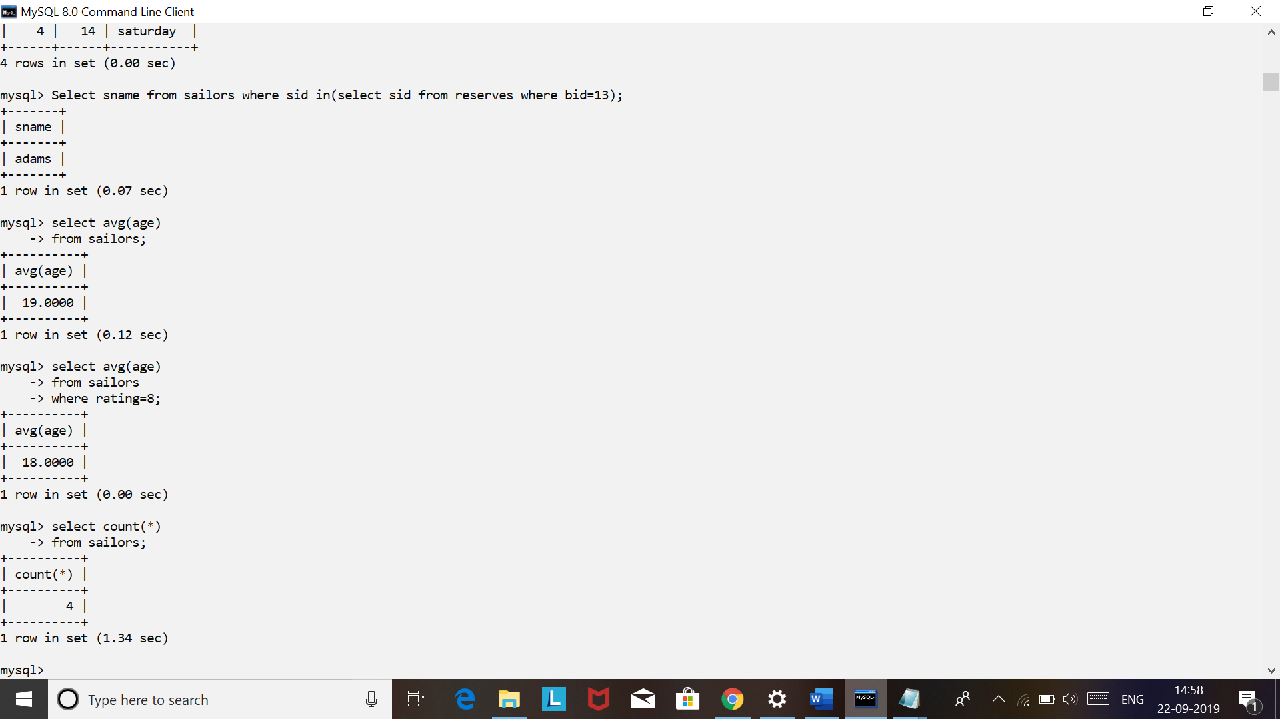

1. **Find oldest sailor with rating 8**

